

**Taste Trail**

Submitted In Partial Fulfillment of Requirements

For the Degree Of

**Bachelor of Science**

**(Computer Science Hons)**

By

**Rohit Vijay Patil**

Roll No: 31011122062

Guide

**Mr. Shriniwas Acharya**



**S K Somaiya College**

Somaiya Vidyavihar University

Vidyavihar, Mumbai - 400 077

**2022-25**

**Somaiya Vidyavihar University**

**SK Somaiya College**

**Certificate**

This is to certify that the project report on **Taste Trail** is a bonafide record of the project work done by **Mr. Rohit Vijay Patil** in the year 2024-25 under the guidance of **Mr. Shriniwas Acharya** Department of Information technology and computer science in partial fulfillment of requirement for the Bachelor of Science degree in Computer Science Hons of Somaiya Vidyavihar University.

______________________ _______________________

Mr. Shriniwas Acharya Ms. Minal Dive

(Guide) (Programme Coordiantor)

_____________________ _____________________

Dr. Swati Maurya Dr. Neetin Desai

(Head of the Department) (Dean and Professor)

Date:

Place: Mumbai-77

**Somaiya Vidyavihar University**

**S K Somaiya College**

**Certificate of Approval of Examiners**

This is to certify that the project report on **Taste Trail** is a bonafide record of the project work done by **Mr. Rohit Vijay Patil** in partial fulfillment of the requirement for the Bachelor of Science degree in **Computer Science Hons** of Somaiya Vidyavihar University.

_________________ _________________

External Examiner /Expert Internal Examiner/ Guide

Date:

Place: Mumbai-77

**Somaiya Vidyavihar University**

**S K Somaiya College**

**DECLARATION**

I declare that this written report submission represents the work done based on my and / or others’ ideas with adequately cited and referenced the original source. I also declare that I have adhered to all principles of academic honesty and integrity as I have not misinterpreted or fabricated or falsified any idea/data/fact/source/original work/ matter in my submission.

I understand that any violation of the above will be cause for disciplinary action by the college and may evoke the penal action from the sources which have not been properly cited or from whom proper permission is not sought.

**_______________________________**

**Signature of the Student**

**Rohit Vijay Patil**

**Name of the Student**

**31011122062**

**Roll No.**

Date:

Place: Mumbai-77

**Abstract**

The objective of this project is to develop a food app which is accessible and seamlessly integrates restaurant discovery, recipe discovery, and watching video content into a strong technological platform which is compatible with Android, iOS, web, and desktop. As the demand for accessible food grows, the app aims to provide users with an easy-to-use interface that allows them to find restaurants near them, find recipes from selected ingredients, and watch related YouTube videos to enhance cooking instructions.

While the food apps of today offer little functionality, they lack a complete user experience. Among the typical issues are few recipes, the lack of embedded video content, and the lack of proper personalization options. The food app proposed in this paper addresses these problems by offering a vast library of recipes, marking favorite recipes, and offering convenient access to tutorial videos, thus making it easy for users to follow while cooking.

Apart from its core features, the app will also have advanced search capabilities to complement a bookmarking system that is easy to use and supports quick access to favorite recipes and videos. The app will emphasize user satisfaction and engagement through the creation of a community-based platform that enables users to share tips and experiences related to cooking.

Security and user privacy are of utmost importance in this project, and arrangements will be made to provide user data security. By combining functionality, security, and a pleasurable user experience, this food app will aim to be an ultimate guide for food enthusiasts, making cooking a fun and easy experience for everyone.

**Acknowledgement**

I would like to take this opportunity to express my sincere thanks and gratitude to **S.K Somaiya College**, for providing me with a platform to pursue my studies and carry out my final project.

I have great pleasure in expressing my deep sense of gratitude to **Dean & Professor, Dr. Neetin Desai**, for his constant encouragement.

I would like to thank **Dr. Swati Maurya**, Head of the Department of Computer Science, and **Ms. Minal Dive**, Coordinator of the Department, who have been constant supports and encouragements throughout the course of this project.

I would also like to extend a special vote of thanks to my project guide, **Mr. Shriniwas Acharya**, for his most sincere and encouraging contribution throughout the project and for providing me with the appropriate resources to enhance my work.

Finally, I would like to thank my parents and friends for all their moral support they have provided during the completion of this work.

***Key words*:** Food, Authentication, security, Flutter, API

**Index**

|  |  |  |  |  |  |  |  |
| --- | --- | --- | --- | --- | --- | --- | --- |
|  | **Table of Contents** | | | | | |  |
| **1** | **Introduction** | | | | | |  |
|  | 1.1 | | Introduction | | | | 9 |
|  | 1.2 | | Background | | | | 12 |
|  | 1.3 | | Objectives | | | | 14 |
|  | 1.4 | | Purpose, Scope and Applicability | | | | 15 |
| **2** | **Survey of Technologies** | | | | | | 17 |
| **3** | **Requirements and Analysis** | | | | | |  |
|  | 3.1 | | Problem Definition | | | | 23 |
|  | 3.2 | | Requirements Specification | | | | 21 |
|  | 3.3 | | Project SDLC Model | | | | 26 |
|  | 3.4 | | Planning and Scheduling | | | | 29 |
|  | 3.5 | | Software and Hardware Requirements | | | | 32 |
|  | 3.6 | | Preliminary Product Description | | | | 36 |
|  | 3.7 | | Conceptual Models | | | | 37 |
|  |  | | 3.7.1 | | | Use Case Diagram | 37 |
|  |  | | 3.7.2 | | | DFD Level Diagram | 38 |
|  |  | | 3.7.3 | | | ER Diagram | 39 |
|  |  | | 3.7.4 | | | Class Diagram | 40 |
| **4** | **System Design** | | | | | |  |
|  | 4.1 | Basic Modules | | | | | 41 |
|  | 4.2 | Data Design | | | | | 42 |
|  | 4.3 | Procedural Design | | | | | 44 |
|  | 4.4 | User Interface Design | | | | | 47 |
|  | 4.5 | Security Issues | | | | | 53 |
|  | 4.6 | Test Cases Design | | | | | 55 |
| **5** | **Implementation and Testing** | | | | | |  |
|  | 5.1 | | | Implementation Approaches | | | 57 |
|  | 5.2 | | | Coding Details and Coding Efficiency | | | 59 |
|  | 5.3 | | | Testing Approach | | | 76 |
|  | 5.4 | | | Modifications and Improvements | | | 78 |
|  | 5.5 | | | Test Cases | | | 79 |
| **6** | **Results and Discussion** | | | | | |  |
|  | 6.1 | | | | Test Reports | | 84 |
|  | 6.2 | | | | User Documentation | | 89 |
| **7** | **Conclusions** | | | | | |  |
|  | **7.1** | | | | Conclusion | | 93 |
|  | **7.2** | | | | Limitations of the System | | 95 |
|  | **7.3** | | | | Future Scope of the Project | | 96 |
| **References** | | | | | | | 97 |





**List of Figures**

|  |  |  |
| --- | --- | --- |
| **Sr. No.** | **Name of the Figure** | **Page No.** |
| 1. | Gantt Chart (Planning and scheduling) | 31 |
| 2 | Use Case Diagram | 37 |
| 3 | Data Flow Diagram | 38 |
| 4 | ER Diagram | 39 |
| 5 | Class Diagram | 40 |

1. **Introduction**
   1. **Introduction**

In today's fast-paced world, the demand for convenient and accessible culinary solutions has never been higher. With the rise of food enthusiasts and home cooks, there is a growing need for applications that not only help users discover nearby dining options but also empower them to create delicious meals at home. This application aims to bridge that gap by providing a comprehensive platform that allows users to search for restaurants within a 5000-meter radius, explore recipes based on selected ingredients, and access instructional videos to enhance their cooking skills. Utilizing Firebase as its database, the app ensures real-time data synchronization and a seamless user experience across multiple platforms, including Android, iOS, web, and desktop.

The application features a user-friendly interface with essential functionalities, including a login and registration system, a home page with a bottom navigation bar, and four key sections: restaurant search, recipe search, bookmarked recipes, and settings. Users can easily navigate through these sections to find what they need, whether it's directions to a nearby restaurant or a new recipe to try at home. By integrating features such as bookmarking and video tutorials, the app not only enhances the cooking experience but also fosters a sense of community among users who share a passion for food.

**Literature Review**

The intersection of food and technology has gained more attention in the past decade with a broad range of studies on the impact of technological advancements on the cooking and eating habits of individuals. Greater research indicates the significant impact of mobile apps on cooking habits, food choice, and consumption behaviors. Cooking apps are now crucial tools that aid in making the optimal meal choices with a mix of convenience, ease of use, and personalization (Smith et al., 2020). With the growing use of smartphones and the need for mobile cooking assistance, these apps are digital companions in home kitchens and social dining spaces.

Restaurant discovery, recipe discovery, and meal planning apps show considerable efficacy in promoting user engagement and satisfaction levels. Johnson and Lee (2019) believe that apps with features like geolocation, user feedback, and visual media provide a more engaging experience. Besides facilitating users in discovering new restaurants, these features promote experimenting with new cuisines and methods. Apps that offer user ratings, dietary filters, and cooking timers also improve user retention by supporting a greater diversity of culinary needs.

Despite the widespread use of food-based mobile applications, most problems remain unsolved. One of the biggest limitations on modern platforms is the lack of adequate personalization and interactivity. The majority of existing applications offer static or typical information, which could potentially be unable to cater to the unique tastes, dietary needs, or skill levels of specific users (Brown & Taylor, 2021). Incompatibility is typically the source of a mismatch between the provided service of the app and user expectations, thus decreasing long-term utilization.

Over the past few years, multimedia elements—particularly video—have been proven to be an effective means of overcoming this problem. Garcia et al. (2022) found that video tutorials significantly improve users' comprehension of complex cooking techniques over text presentation. Videos have the ability to provide step-by-step directions, visual presentations, and even immediate feedback, which makes them highly beneficial for novice cooks or cooks trying out new recipes. Additionally, the use of video content provides a more interactive and student-centered learning process, which can better explain cooking skills and encourage users' confidence in the cooking process.

In addition to content innovations, advances in backend infrastructure technology have enabled more versatile application functionality. Cloud-based services like Google Firebase have become immensely popular among developers due to scalability, real-time data synchronization, and simplicity of integration with mobile operating systems (Miller, 2021). Such technologies enable applications to manage user preferences, ensure data consistency across sessions, and deliver personalized content in real-time. Favorite recipes can be bookmarked, customized ingredient lists can be stored, and data synchronization across devices are enabled by cloud databases, greatly enhancing the user experience.

Also, the awareness of the potential of data analytics and machine learning is growing in this area. Predictive models can look at user behavior to suggest recipes or restaurants, and also personalize content based on cooking history or dietary goals. While this is a new area, the integration of smart systems offers a promising path to improve personalization of food experiences in a meaningful way. In conclusion, existing literature indicates a definite scope for innovation in mobile apps for food lovers. By overcoming the shortcomings of existing platforms, most notably the absence of interactivity and customization, developers can design more interactive, user-centric tools. By leveraging technologies like Firebase for real-time data handling, rich multimedia content, and deliberate UI/UX design, it is feasible to design a holistic application that serves culinary enthusiasts from beginning to end. Such an application can transform contemporary cooking and dining experiences, making them more enjoyable, informative, and accessible.

* 1. **Background**

Over the past few years, the food scene has also dramatically changed, driven by the increasing phenomenon of home cooking and the advent of food ordering apps. As more and more individuals work towards improving their culinary skills and researching new dining venues, there has been an unprecedented demand for extensive food apps. These apps serve as fundamental aids for consumers, enabling them to search for local restaurants, navigate different recipes, and provide cooking lessons. Yet, even though numerous food apps exist, there remains a dearth of delivering an extensive and unified experience that combines restaurant discovery with recipe exploration and learning material.

The suggested food application seeks to fill this gap by providing an easy-to-use interface to enable users to locate restaurants in a given radius, search recipes for chosen ingredients, and obtain related video content. With Firebase as its database, the app provides real-time synchronization of data and allows for a seamless user experience across various platforms, ranging from Android and iOS to web and desktop platforms.

**Existing System:**

Today, we have a multitude of food applications out there that compete in terms of a series of features with which to facilitate the eating experience. Such widely popular applications as Yelp, Zomato, and Allrecipes allow users to find restaurants and recipes, respectively. Such sites commonly provide user-provided reviews, ratings, and simple search functionality. Still, they exist as stand-alone, either in terms of finding restaurants or recipes, without uniting the two in a unified experience.

Additionally, the majority of recent cooking applications lack interactive features that enable user engagement. While some of them offer basic recipe steps, they might lack video tutorials or the ability to bookmark favorite recipes for easy retrieval. Additionally, the user interfaces of the applications might at times be cluttered or confusing, thereby deterring users from being able to navigate and retrieve the desired information easily.

**Disadvantages of the Existing System:**

1. **Limited Integration:** The majority of current food apps deal with either the discovery of restaurants or the searching of recipes but do not offer a single platform that combines both the features. This division compels the users to alternate between several applications to meet their food requirements.
2. **Lack of Interactive Content:** Most of the apps lack video tutorials or interactive content, which can enhance the cooking experience. Without visual demonstration, users cannot achieve complex recipes, and the outcome is frustration and poor engagement.
3. **Lack of Personalization:** Current systems usually lack personalized elements, including bookmarking or saving favorite recipes, which usually have a negative effect on user satisfaction and retention. Users are inconvenienced when they have to continue searching for the same recipes or dining options.
4. **User Interface Problems:** Certain food applications have complex or non-standard interfaces, which hinders the user from easily navigating and accessing relevant information in a timely fashion. Poor user experience can result in less usage and increased dissatisfaction among users.
5. **Restricted Search Functionality:** The majority of apps do not have advanced search functionality, for example, the ability to search recipes by single ingredients or specific dietary needs. This can restrict users from accessing suitable recipes that meet their needs.
6. **Synchronization issues with data:** Existing software might not be using real-time databases, thus resulting in lags in updating the data and incomplete synchronization between devices. Therefore, users might not be able to use the latest content or updates to their stored preferences.
   1. **Objectives**

**Restaurant Discovery**: Enable users to search for nearby restaurants within a 5000-meter radius, providing them with a variety of dining options based on their location.

**Directions Integration**: Offer users the ability to get directions to selected restaurants via Google Maps, ensuring a seamless navigation experience.

**Recipe Search Functionality**: Allow users to search for recipes based on selected ingredients, helping them utilize what they have on hand and reduce food waste.

**Detailed Recipe Instructions**: Provide comprehensive preparation instructions for each recipe, ensuring users can easily follow along and recreate dishes at home.

**Video Tutorials**: Integrate instructional YouTube videos for each recipe, offering users visual guidance to enhance their cooking skills and understanding of techniques.

**Bookmarking System**: Implement a bookmarking feature that allows users to save their favourite recipes for easy access later, enhancing user engagement and satisfaction.

**User -Friendly Interface**: Design an intuitive and visually appealing user interface that simplifies navigation and enhances the overall user experience across all platforms.

**Settings Customization**: Provide users with options to customize their experience, including the ability to switch between light and dark themes and manage their account settings.

**Secure Authentication**: Ensure user data protection and privacy through secure authentication methods, utilizing Firebase for reliable user account management.

**Cross-Platform Accessibility**: Develop the application to be accessible on multiple platforms (Android, iOS, web, and desktop), ensuring users can enjoy a consistent experience regardless of their device.

* 1. **Purpose, Scope and Applicability**

**Purpose**

The overall purpose of the food application is to provide users with a comprehensive platform that combines restaurant discovery, recipe lookup, and tutorial video content. Through the provision of an intuitive interface and requisite features, the application aims to enhance the cuisine experience for users who have an enthusiastic interest in eating and cooking. The application aims to enable users with the capability to make educated decisions when it comes to their meals, whether dining away from home or preparing meals within their homes.

**Some Important Purpose**

1. **Enhancing Culinary Ability:** The app is intended to enhance users' culinary ability by providing detailed recipes and teaching videos, hence making the learning of new methods and the discovery of varied dishes easier.
2. **Reducing Food Waste:** By facilitating users to search for recipes with ingredients already on hand, the app encourages the use of already available resources, thereby reducing food wastage and promoting sustainable measures.
3. **Facilitated Meal Selections:** The restaurant discovery mode enables users to find local meal options easily, thus making it easier to find varied meal experiences and consume meals away from home without the added weight of significant searching.
4. **Community Involvement:** The application creates a feeling of belonging among food lovers by the provision of a platform where people can exchange experiences, tips, and favorite recipes, thereby creating a culinary inspiration and exchange platform.
5. **Customized User Experience:** Through the provision of features like bookmarking and setting adjustability, the app strives to provide an experience that is tailored to the individual needs and preferences of each user.

**Scope**

The domain of the food application includes a wide range of functionalities for the sake of meeting the varied requirements of food lovers. The application is intended to be a helpful guide for individuals who want to find restaurants, explore recipes, and learn cooking. It will include features such as a restaurant search feature that will enable users to search for dining places within a radius, along with directions and information. Additionally, the recipe search feature will enable users to enter chosen ingredients and get a list of related recipes, along with step-by-step instructions and video tutorials.

In addition, the app will also include a bookmarking functionality, enabling users to bookmark their favorite recipes for future reference. The functionality will probably increase user interaction and invite individuals to use the app multiple times. The functionality of setting customization will give users the power to customize their experience, such as theme and notification settings options. The app will be built on multiple platforms to ensure usability by users on Android, iOS, web, and desktop platforms. Overall, the project scope aims to build a complete and interactive food experience that meets the needs of contemporary food enthusiasts.

**Applicability**

The functionality of the food application transcends across a broad segment of consumers such as amateur cooks, food enthusiasts, and consumers in search of convenient food. For the amateur cook, the application is an essential guide to learning new recipes and general cooking skills. With the provision of easy-to-understand instructions and tutorial videos, the application makes it possible for consumers to work with a variety of types of cuisine and methods of cooking, thus providing the confidence needed within the cooking arena. This comes in handy for novice cooks who are timid when exposed to complex recipes, since the application breaks down the process of cooking into more comprehensible phases. Apart from being helpful to home cooks, the application is also very helpful to frequent eaters or people who take take-out. The restaurant locator tool helps users find a variety of dining places based on their location, thus making it easy to find new restaurants. This tool is especially helpful to people who frequently travel or are in new environments, as the app provides useful information about local dining places, including user reviews and directions. By making it easy to find dining places, the app enhances the dining experience of its users. Additionally, the focus of the application to reduce food wastage and promote sustainability aligns with the growing trend of conscious consumerism. As more people become aware of the environmental implication of wastage of food, the functionality of finding recipes based on ingredients readily available at home promotes users to be sustainable in their own kitchen activities. Based on readily available resources, users can minimize wastage and help create a more sustainable food environment. Overall, the usability of the food application is broad, meeting the needs of multiple user groups and promoting kitchen experimentation and sustainability.

1. **survey of Technologies**

The development of the Taste Trial project relies on a meticulously curated technology stack, encompassing frontend, backend, and hardware components. Each element plays a crucial role in shaping the functionality, performance, and user experience of the application.

* 1. **Selected Technology**
* **FRONTEND**
* **Flutter:** Flutter is an open-source UI framework for developing software, developed by Google, intended to make the development of natively compiled mobile, web, and desktop applications possible from a shared codebase. It dramatically cuts down on development time and effort since developers can write code once and deploy it on different platforms. Flutter offers a deep collection of pre-styled widgets and utilities that enable visually rich and interactive user interfaces. Its widget-oriented design makes high customization and flexibility possible, making it easy to create sophisticated UIs. Furthermore, Flutter optimizes its performance for smooth animation and transition, making the user experience richer.
* **Dart:** Dart is the programming language supported by Flutter, and it was designed for the creation of user interfaces. It is an object-oriented language that supports features like strong typing, async/await support, and a large standard library. One of the most popular features of Dart is "hot reload," through which developers can view changes in real-time without needing to restart the application. This feature considerably accelerates the development process since developers can iteratively work on their designs and functionality very rapidly. Dart is simple to learn, so both beginners and advanced developers can use it, and its performance on mobile apps ensures that applications perform well on all devices.
* **UI/UX Design:** Applying current design principles and user experience tactics is important for developing an engaging app. An attractive user interface not only appeals to users but also improves usability and satisfaction. Using design software such as Figma or Adobe XD can assist in creating intuitive interfaces that improve user interaction. The tools enable designers to make wireframes, prototypes, and high-fidelity mockups, making collaboration between developers and designers easier. Adhering to best practices in UI/UX design, including being consistent, ensuring accessibility, and giving users feedback, can make the app deliver a seamless and enjoyable experience to users.
* **BACKEND**
* **Firebase:** Firebase is a complete platform offering multiple backend services, making development easier for web and mobile applications. It is a set of tools that encompass real-time databases, cloud storage, authentication, hosting, and analytics. Developers can use Firebase to concentrate on developing features and functionality without needing to manage servers or infrastructure. Firebase integrates with Flutter smoothly, making it easy for developers to integrate their frontend and backend systems. Firebase also offers excellent documentation and community support, making it simpler for developers to debug problems and follow best practices.
* **Firebase Firestore:** Firestore is a NoSQL cloud database that supports storing, synchronizing, and querying data in real-time. It is built to automatically scale, supporting different levels of data and user traffic without the need for manual intervention. Firestore allows offline access to data, which means users can use the app even when they are offline. This is especially useful for mobile apps, as it improves user experience by providing uninterrupted access to data. Firestore's data model is highly flexible, enabling developers to structure data in collections and documents, making it simple to organize and retrieve data in a cost-effective and efficient manner.
* **Firebase Authentication:** Firebase Authentication offers a safe and convenient user authentication system. It enables different sign-in mechanisms like email/password, phone number, and social media (Google, Facebook, etc.) sign-ins, providing a smooth experience for users. The Firebase Authentication integration enables developers to add user registration, login, and account management functionality with little effort. Firebase Authentication also comes with pre-built security features, including email verification and password reset, to secure user accounts. This service not only strengthens security but also enhances user satisfaction and trust.
* **DATABASE**
* **Firestore Database Structure:** Data organization in Firestore is achieved by creating documents and collections. Any collection may have many documents, and these documents can hold user data, recipes, restaurant data, and so on. With this hierarchical database, efficient querying and fetching of data are possible because developers can retrieve specific documents with ease depending on user interactions. Firestore's handling of advanced data types like arrays and nested objects adds to its flexibility. It's also possible to have sub-collections within a document, to provide a structured and scalable data structure that is extensible in its growth for the application.
* **Security Rules:** Firestore security rules should be put in place to secure user information. Security rules specify who is able to read or write data, so that sensitive information is not exposed but required interactions are permitted. Rules can be defined by developers on the basis of user authentication, document fields, and other conditions, allowing for fine-grained control over data access. This level of security is essential in order to sustain user trust, particularly in apps dealing with personal data or sensitive information. Regular audits and updating of security rules are also advised in order to keep up with evolving needs and possible vulnerabilities. By putting security first, developers can design a secure platform for users to engage with the app, which eventually translates to greater user retention and satisfaction.

**IDE (Integrated Development Environment):**

**1.Visual Studio Code:**

Visual Studio Code, commonly referred to as VS Code, is a versatile source-code editor developed by Microsoft, compatible with Windows, Linux, macOS, and web browsers. It offers a wide array of features that make it an ideal choice for developing a food application. Key functionalities include support for debugging, syntax highlighting, intelligent code completion, snippets, code refactoring, and integrated version control with Git. Given VS Code's numerous extensions, efficiency, and adaptability, it is particularly well-suited for this project.

For Flutter development, VS Code provides robust support through dedicated extensions that enhance the development experience. The lightweight yet powerful code editor includes features such as built-in Git integration for seamless version management, IntelliSense for intelligent code completion, and an extensive debugging toolkit that simplifies the process of identifying and resolving issues. Its user-friendly interface and customizable layout significantly boost productivity, allowing developers to focus on building a high-quality application.

Moreover, VS Code's smooth integration with Dart and Flutter SDKs streamlines the development of the frontend, while its extensive marketplace of extensions allows developers to tailor the environment to meet the unique requirements of the food app project. This adaptability makes VS Code a perfect option for creating and managing complex applications, ensuring that developers can efficiently implement features such as restaurant discovery, recipe search functionality, and user authentication. Overall, Visual Studio Code serves as an excellent development environment for the food application, combining powerful tools with flexibility to enhance the overall development process.

* **HARDWARE:**

Processor : Intel(R) Core (TM) i5-1235U

RAM : 256 MB

Hard Disk : 8 GB

Memory : 32 MB

Keyboard : 80 keys

Mouse : 1

Monitor : 1

1. **Requirements Analysis**

**3.1 Problem Definition**

In today's fast-paced world, food enthusiasts and everyday cooks often face challenges in discovering dining options and exploring culinary experiences. With the abundance of restaurants and recipes available, users struggle to make informed decisions about where to eat or what to cook. This project aims to address these challenges by developing a comprehensive food application that integrates restaurant discovery, recipe exploration, and instructional content, providing users with a seamless and engaging culinary experience.

**Problem Description**

The goal of this project is to create a food application that replicates the convenience and functionality that users expect from modern culinary platforms. The application will incorporate essential features such as user authentication, restaurant discovery, recipe search based on available ingredients, and detailed cooking instructions. Utilizing cutting-edge technologies like Flutter for the frontend and Firebase for the backend, the app will ensure a smooth user experience while adhering to best practices in mobile app development, including responsive design, secure authentication, and real-time data synchronization.

**Objectives:**

1. **Develop a Comprehensive Food Application**: Create an app that includes core functionalities such as user registration, authentication, restaurant discovery, recipe browsing, and instructional video content.
2. **Utilize Flutter for Frontend Development**: Implement Flutter to build a visually appealing and responsive user interface that enhances user engagement and interaction.
3. **Leverage Firebase for Backend Services**: Use Firebase Firestore for real-time data storage and synchronization, ensuring that users have access to the latest information about restaurants and recipes.
4. **Incorporate Firebase Authentication**: Implement secure user authentication methods, allowing users to register, log in, and manage their accounts safely.
5. **Enable Recipe Search Functionality**: Allow users to search for recipes based on selected ingredients, helping them utilize what they have on hand and reduce food waste.
6. **Provide Detailed Cooking Instructions and Video Tutorials**: Offer comprehensive preparation instructions and integrate instructional videos to enhance users' cooking skills and confidence in the kitchen**.**
7. **Implement a Bookmarking System**: Create a feature that allows users to save their favourite recipes for easy access later, promoting user engagement and satisfaction.
8. **Design a User-Friendly Interface**: Focus on creating an intuitive and visually appealing interface that simplifies navigation and enhances the overall user experience across all platforms.
9. **Ensure Cross-Platform Accessibility**: Develop the application to be accessible on multiple platforms (Android, iOS, web, and desktop), ensuring users can enjoy a consistent experience regardless of their device.
10. **Share the Source Code as an Open-Source Project**: Contribute to the developer community by making the source code available for others to learn from, collaborate on, and build upon.
    1. **Requirements Specification**

**1. User Management**

* User Registration: Users should be able to create an account using email/password or social media logins (e.g., Google, Facebook).
* User Profiles: Each user will have a profile that includes personal information, favourite recipes, and bookmarked restaurants.
* Profile Management: Users should be able to update their profile information, including their display name, profile picture, and preferences.
* Password Recovery: Implement a password recovery feature that allows users to reset their passwords via email.

**2. Authentication and Authorization**

* Secure Authentication: Utilize Firebase Authentication to manage user sign-up and login processes securely.
* Session Management: Implement session management to keep users logged in across sessions while allowing them to log out when desired.
* Role-Based Access Control: Define user roles (e.g., regular users, admin) to manage access to certain features, such as content moderation or analytics.

**3. User Interface (UI) and Experience (UX)**

* Responsive Design: Ensure the application is responsive and provides a consistent experience across various devices (mobile, tablet, desktop).
* Intuitive Navigation: Design a user-friendly navigation system that allows users to easily access different sections of the app (e.g., home, recipes, restaurants, profile).
* Visual Appeal: Use modern design principles and aesthetics to create an engaging and visually appealing interface.
* Dark/Light Mode: Provide users with the option to switch between dark and light themes for better accessibility and personalization.

**4. Security and Privacy**

* Data Encryption: Ensure that sensitive user data, such as passwords and personal information, is encrypted both in transit and at rest.
* Privacy Policy: Develop a clear privacy policy that outlines how user data is collected, used, and protected.
* Secure API Calls: Implement secure API calls to prevent unauthorized access to backend services and user data.
* User Consent: Obtain user consent for data collection and provide options for users to manage their privacy settings.

**5. Performance and Scalability**

* Real-Time Data Sync: Utilize Firebase Firestore's real-time capabilities to ensure that data updates are reflected instantly across all connected clients.
* Optimized Load Times: Optimize the application for fast load times, ensuring that users can access content quickly and efficiently.
* Scalable Architecture: Design the application architecture to handle increased user traffic and data volume without compromising performance.
* Caching Mechanisms: Implement caching strategies to reduce server load and improve response times for frequently accessed data.

**6. Documentation and Testing**

* Comprehensive Documentation: Provide thorough documentation for both users and developers, including user guides, API documentation, and setup instructions.
* Unit Testing: Implement unit tests for critical components of the application to ensure functionality and reliability.
* Integration Testing: Conduct integration testing to verify that different parts of the application work together seamlessly.
* User Acceptance Testing (UAT): Involve real users in testing the application to gather feedback and identify areas for improvement before the final release.

**7. Deployment**

* Continuous Integration/Continuous Deployment (CI/CD): Set up a CI/CD pipeline to automate the deployment process, ensuring that updates can be released quickly and reliably.
* Cloud Hosting: Deploy the application on a cloud platform (e.g., Firebase Hosting, AWS, or Google Cloud) to ensure scalability and availability.
* Monitoring and Analytics: Implement monitoring tools to track application performance, user engagement, and error reporting, allowing for proactive maintenance and improvements.
* Version Control: Use version control (e.g., Git) to manage code changes and facilitate collaboration among developers.

**8. Recipe Search by Ingredients**

* Ingredient Input: Users can input one or more ingredients they have on hand to find suitable recipes.
* Recipe Suggestions: The app will suggest recipes that utilize the provided ingredients, helping users minimize food waste and maximize creativity in the kitchen.

**9. Bookmarking**

* Bookmark Recipes: Users can easily bookmark their favourite recipes for quick access later.
  1. **Project SDLC Model**

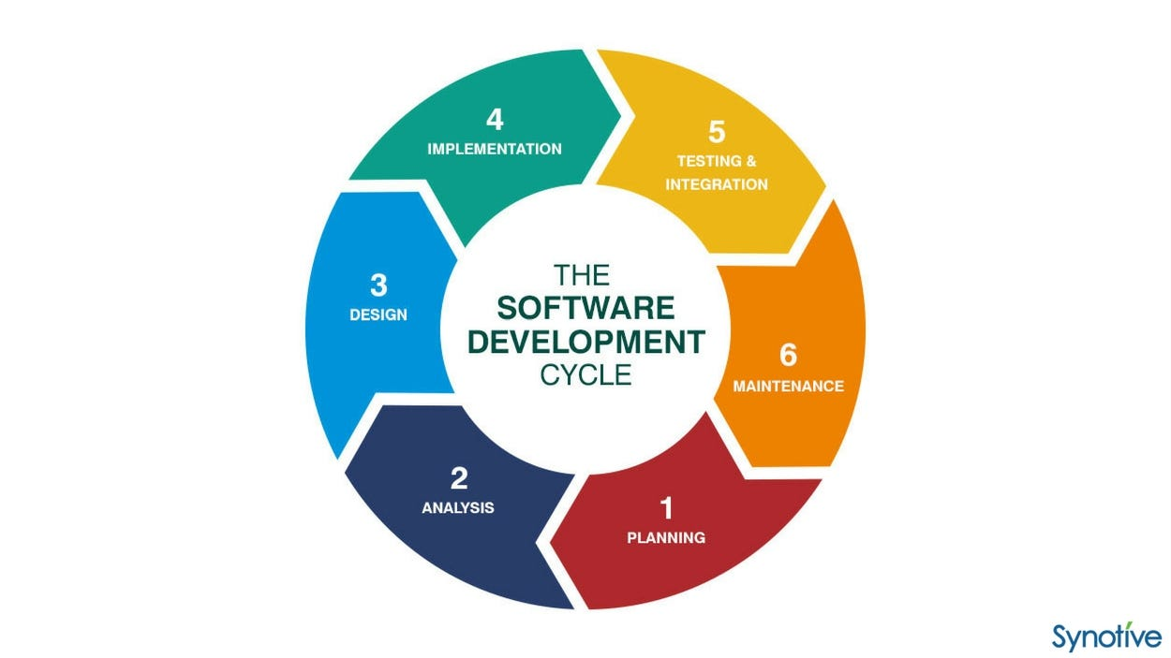

**1. Planning**

* **Project Initiation**: Define the project scope, objectives, and goals. Identify stakeholders and establish a project timeline.
* **Feasibility Study**: Assess the technical, operational, and financial feasibility of the project to ensure it aligns with business goals.
* **Resource Allocation**: Determine the resources required, including team members, tools, and technologies needed for development.

**2. Requirement Gathering**

* **Stakeholder Interviews**: Conduct interviews and surveys with potential users and stakeholders to gather insights on their needs and expectations.
* **Use Case Development**: Create use cases to outline how users will interact with the application and identify key functionalities.
* **Requirement Specification**: Document functional and non-functional requirements, including user management, authentication, recipe search, and security features.

**3. Design and Architecture**

* **System Architecture**: Define the overall architecture of the application, including frontend, backend, and database components.
* **UI/UX Design**: Create wireframes and prototypes for the user interface, focusing on usability and visual appeal.
* **Database Design**: Design the database schema, including collections and relationships for storing user data, recipes, and restaurant information.

**4. Development**

* **Frontend Development**: Implement the user interface using Flutter, ensuring responsiveness and a seamless user experience.
* **Backend Development**: Develop the backend services using Firebase, including authentication, data storage, and API endpoints.
* **Integration**: Integrate frontend and backend components, ensuring smooth communication between the two.

**5. Testing**

* **Unit Testing**: Conduct unit tests for individual components to ensure they function correctly.
* **Integration Testing**: Test the interaction between frontend and backend components to verify that they work together as intended.
* **User Acceptance Testing (UAT)**: Involve real users in testing the application to gather feedback and identify any issues before the final release.
* **Performance Testing**: Assess the application's performance under various conditions to ensure it meets scalability and responsiveness requirements.

**6. Deployment**

* **Deployment Planning**: Prepare for deployment by setting up the production environment and ensuring all components are ready.
* **Cloud Hosting**: Deploy the application on a cloud platform (e.g., Firebase Hosting) to ensure scalability and availability.
* **Launch**: Officially launch the application to users, making it accessible for download and use.

**7. Documentation**

* **User Documentation**: Create user guides and tutorials to help users navigate and utilize the application effectively.
* **Technical Documentation**: Document the codebase, architecture, and APIs to facilitate future development and maintenance.
* **Maintenance Guides**: Provide guidelines for ongoing maintenance and support, including troubleshooting common issues.

**8. Maintenance and Support**

* **Bug Fixes**: Address any issues or bugs reported by user’s post-launch, ensuring a smooth user experience.
* **User Support**: Establish a support system for users to report issues, ask questions, and receive assistance.
* **Regular Updates**: Implement regular updates to improve functionality, security, and performance based on user feedback and technological advancements.

**9. Continuous Improvement**

* **User Feedback Collection**: Continuously gather feedback from users to identify areas for improvement and new feature requests.
* **Feature Enhancements**: Plan and implement new features and enhancements based on user needs and market trends.
* **Performance Monitoring**: Monitor application performance and user engagement metrics to identify opportunities for optimization and growth.
  1. **Planning and Scheduling**

**Planning**

* **Project Initiation** (2 days)
  + Define project scope, objectives, and goals.
  + Identify stakeholders.
  + Establish a project timeline.
* **Feasibility Study** (2 days)
  + Assess technical, operational, and financial feasibility.
* **Resource Allocation** (1 day)
  + Determine required resources, including team members and tools.

**Requirement Gathering**

* **Stakeholder Interviews** (3 days)
  + Conduct interviews and surveys with potential users and stakeholders.
* **Use Case Development** (2 days)
  + Create use cases to outline user interactions and key functionalities.
* **Requirement Specification** (2 days)
  + Document functional and non-functional requirements.

**Design and Architecture**

* **System Architecture** (4 days)
  + Define overall architecture, including frontend, backend, and database components.
* **UI/UX Design** (5 days)
  + Create wireframes and prototypes for the user interface.
* **Database Design** (2 days)
  + Design the database schema for user data, recipes, and restaurant information. OR generate the API for integration instead of database.

**Development (Part 1)**

* **Frontend Development** (7 days)
  + Implement the user interface using Flutter.
* **Backend Development** (5 days)
  + Develop backend services using Firebase, including authentication and data storage.

**Development (Part 2)**

* **Backend Development (continued)** (3 days)
  + Complete backend services and API endpoints.
* **Integration** (3 days)
  + Integrate frontend and backend components for smooth communication.

**Testing**

* **Unit Testing** (2 days)
  + Conduct unit tests for individual components.
* **Integration Testing** (2 days)
  + Test interaction between frontend and backend components.
* **User Acceptance Testing (UAT)** (2 days)
  + Involve real users in testing to gather feedback.

**Testing (continued) and Deployment**

* **Performance Testing** (2 days)
  + Assess application performance under various conditions.
* **Deployment Planning** (2 days)
  + Prepare for deployment by setting up the production environment.
* **Cloud Hosting** (1 day)
  + Deploy the application on a cloud platform (e.g., Firebase Hosting).

**Launch and Documentation**

* **Launch** (1 day)
  + Officially launch the application to users.
* **User Documentation** (2 days)
  + Create user guides and tutorials.
* **Technical Documentation** (2 days)
  + Document the codebase, architecture, and APIs.
* **Maintenance Guides** (1 day)
  + Provide guidelines for ongoing maintenance and support.

**Ongoing Maintenance and Support (Post-Launch)**

* **Bug Fixes**: Address any issues reported by users.
* **User Support**: Establish a support system for user inquiries.
* **Regular Updates**: Plan for regular updates based on user feedback.

**Continuous Improvement (Post-Launch)**

* **User Feedback Collection**: Continuously gather feedback for improvements.
* **Feature Enhancements**: Plan and implement new features based on user needs.
* **Performance Monitoring**: Monitor application performance and user engagement.

**Gantt Chart**.

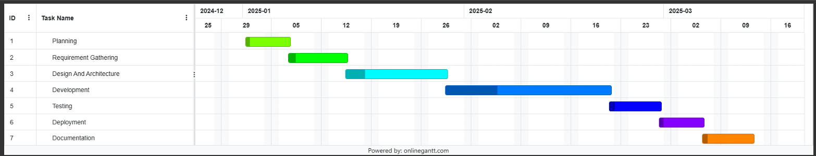

* 1. **Software and Hardware Requirements**
* **SOFTWARE**
* **FRONTEND**
* **Flutter:** Flutter is an open-source UI framework for developing software, developed by Google, intended to make the development of natively compiled mobile, web, and desktop applications possible from a shared codebase. It dramatically cuts down on development time and effort since developers can write code once and deploy it on different platforms. Flutter offers a deep collection of pre-styled widgets and utilities that enable visually rich and interactive user interfaces. Its widget-oriented design makes high customization and flexibility possible, making it easy to create sophisticated UIs. Furthermore, Flutter optimizes its performance for smooth animation and transition, making the user experience richer.
* **Dart:** Dart is the programming language supported by Flutter, and it was designed for the creation of user interfaces. It is an object-oriented language that supports features like strong typing, async/await support, and a large standard library. One of the most popular features of Dart is "hot reload," through which developers can view changes in real-time without needing to restart the application. This feature considerably accelerates the development process since developers can iteratively work on their designs and functionality very rapidly. Dart is simple to learn, so both beginners and advanced developers can use it, and its performance on mobile apps ensures that applications perform well on all devices.
* **UI/UX Design:** Applying current design principles and user experience tactics is important for developing an engaging app. An attractive user interface not only appeals to users but also improves usability and satisfaction. Using design software such as Figma or Adobe XD can assist in creating intuitive interfaces that improve user interaction. The tools enable designers to make wireframes, prototypes, and high-fidelity mockups, making collaboration between developers and designers easier. Adhering to best practices in UI/UX design, including being consistent, ensuring accessibility, and giving users feedback, can make the app deliver a seamless and enjoyable experience to users.
* **BACKEND**
* **Firebase:** Firebase is a complete platform offering multiple backend services, making development easier for web and mobile applications. It is a set of tools that encompass real-time databases, cloud storage, authentication, hosting, and analytics. Developers can use Firebase to concentrate on developing features and functionality without needing to manage servers or infrastructure. Firebase integrates with Flutter smoothly, making it easy for developers to integrate their frontend and backend systems. Firebase also offers excellent documentation and community support, making it simpler for developers to debug problems and follow best practices.
* **Firebase Firestore:** Firestore is a NoSQL cloud database that supports storing, synchronizing, and querying data in real-time. It is built to automatically scale, supporting different levels of data and user traffic without the need for manual intervention. Firestore allows offline access to data, which means users can use the app even when they are offline. This is especially useful for mobile apps, as it improves user experience by providing uninterrupted access to data. Firestore's data model is highly flexible, enabling developers to structure data in collections and documents, making it simple to organize and retrieve data in a cost-effective and efficient manner.
* **Firebase Authentication:** Firebase Authentication offers a safe and convenient user authentication system. It enables different sign-in mechanisms like email/password, phone number, and social media (Google, Facebook, etc.) sign-ins, providing a smooth experience for users. The Firebase Authentication integration enables developers to add user registration, login, and account management functionality with little effort. Firebase Authentication also comes with pre-built security features, including email verification and password reset, to secure user accounts. This service not only strengthens security but also enhances user satisfaction and trust.
* **DATABASE**
* **Firestore Database Structure:** Data organization in Firestore is achieved by creating documents and collections. Any collection may have many documents, and these documents can hold user data, recipes, restaurant data, and so on. With this hierarchical database, efficient querying and fetching of data are possible because developers can retrieve specific documents with ease depending on user interactions. Firestore's handling of advanced data types like arrays and nested objects adds to its flexibility. It's also possible to have sub-collections within a document, to provide a structured and scalable data structure that is extensible in its growth for the application.
* **Security Rules:** Firestore security rules should be put in place to secure user information. Security rules specify who is able to read or write data, so that sensitive information is not exposed but required interactions are permitted. Rules can be defined by developers on the basis of user authentication, document fields, and other conditions, allowing for fine-grained control over data access. This level of security is essential in order to sustain user trust, particularly in apps dealing with personal data or sensitive information. Regular audits and updating of security rules are also advised in order to keep up with evolving needs and possible vulnerabilities. By putting security first, developers can design a secure platform for users to engage with the app, which eventually translates to greater user retention and satisfaction.
* **IDE (Integrated Development Environment):**

**Visual Studio Code**:

* Visual Studio Code, commonly referred to as VS Code, is a versatile source-code editor developed by Microsoft, compatible with Windows, Linux, macOS, and web browsers. It offers a wide array of features that make it an ideal choice for developing a food application. Key functionalities include support for debugging, syntax highlighting, intelligent code completion, snippets, code refactoring, and integrated version control with Git. Given VS Code's numerous extensions, efficiency, and adaptability, it is particularly well-suited for this project.
* For Flutter development, VS Code provides robust support through dedicated extensions that enhance the development experience. The lightweight yet powerful code editor includes features such as built-in Git integration for seamless version management, IntelliSense for intelligent code completion, and an extensive debugging toolkit that simplifies the process of identifying and resolving issues. Its user-friendly interface and customizable layout significantly boost productivity, allowing developers to focus on building a high-quality application.
* Moreover, VS Code's smooth integration with Dart and Flutter SDKs streamlines the development of the frontend, while its extensive marketplace of extensions allows developers to tailor the environment to meet the unique requirements of the food app project. This adaptability makes VS Code a perfect option for creating and managing complex applications, ensuring that developers can efficiently implement features such as restaurant discovery, recipe search functionality, and user authentication. Overall, Visual Studio Code serves as an excellent development environment for the food application, combining powerful tools with flexibility to enhance the overall development process.
* **HARDWARE:**

Processor : Intel(R) Core (TM) i5-1235U

RAM : 256 MB

Hard Disk : 8 GB

Memory : 32 MB

Keyboard : 80 keys

Mouse : 1

Monitor : 1

* 1. **Preliminary Product Description**

The future food app will develop a full-fledged platform for food lovers and average cooks with Flutter as the frontend and Firebase as the backend. The users will have a convenient experience in finding restaurants, browsing recipes, and improving their culinary skills through the application. With its stunning and minimalistic UI, the app will focus on user interaction and happiness.

Secure user authentication for the food app will be offered through Firebase Authentication, allowing users to sign up, log in securely, and update their profiles. With strong security protocols, such as data encryption and privacy control, the application will protect users' personal details and preferences, promoting trust and confidence in the site.

Users will also be able to search recipes on the basis of ingredients found at home, thereby ensuring minimal wastage of food and maximum culinary creativity. The app will further enable users to bookmark their preferred restaurants and recipes for quick recall. Users will also be able to rate and provide feedback on recipes and meals, building a rich community of food enthusiasts.

The consumption of food will be designed with responsiveness to make it fit perfectly on the broad range of devices and screen sizes, whether desktop, tablet, or mobile phone. This consideration for user experience will make it easier to use and access so that users can access the app from anywhere.

In general, the food application will be a one-stop-shop for food discovery with a broad collection of recipes, restaurant discovery, and social connection, security and customer satisfaction being of prime importance.

* 1.  **Conceptual Models**

**3.7.1 Use Case Diagram**

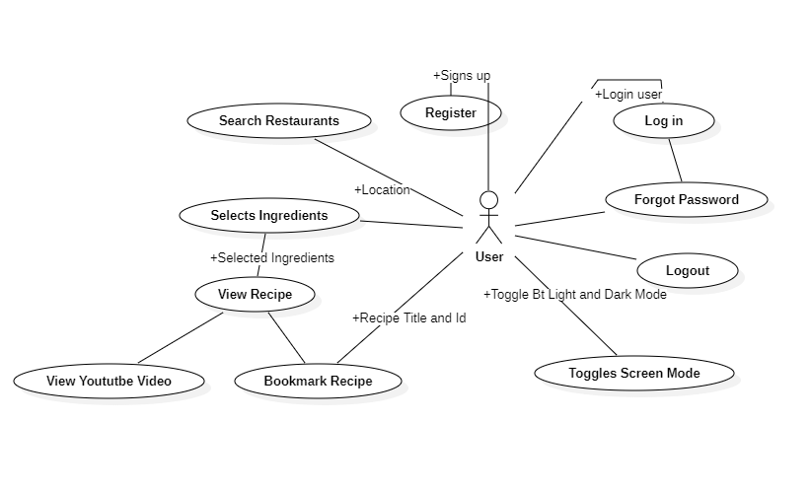

**3.7.2 DFD Level Diagram**

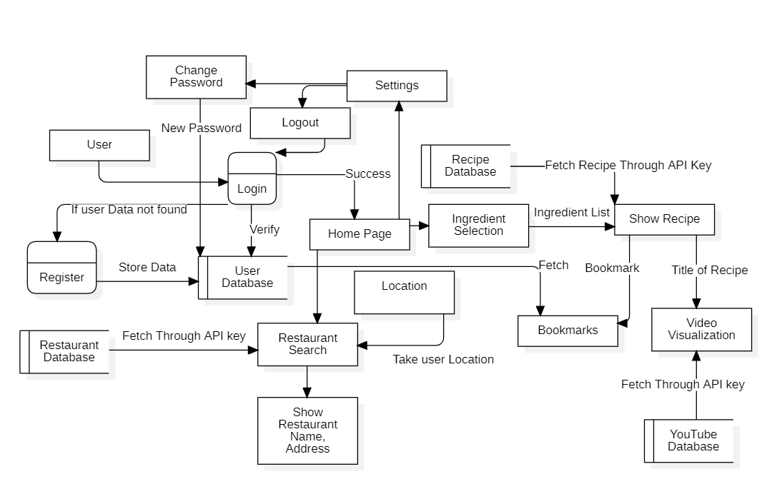

* + 1. **ER Diagram**

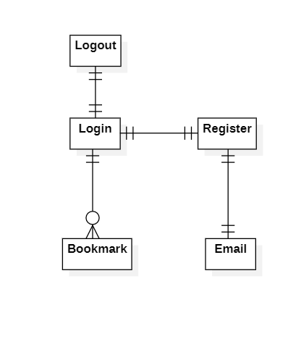

* + 1. **Class Diagram**

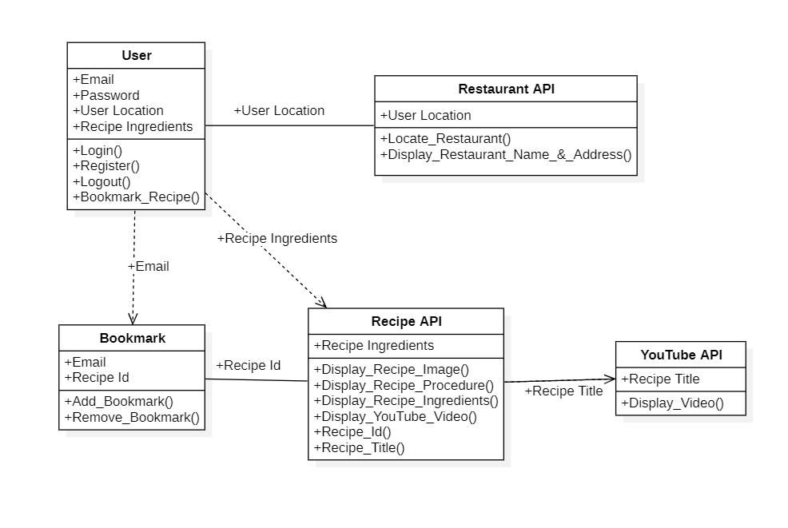

1. **System Design**

Systems Design is the process of defining the architecture, components, modules, interfaces, and data for a system to satisfy specified requirements. It involves translating user requirements into a detailed blueprint that guides the implementation phase.

**4.1 Basic Modules**

The food application features several core modules that, combined, facilitate its principal functionalities to provide users with an effortless culinary experience.

**Authentication Module** takes care of user registration, login, and password management to enable secure entry into the application through Firebase Authentication. It contains account creation, email verification, password reset, and session management functionalities to secure user data and preferences.

**User Profile Module** allows users to personalize their profiles, manage their favorite recipes, and bookmark favorite recipe. Users are able to edit their personal information, contributing to their overall experience in the app.

**Recipe Management Module** allows users to browse through a rich library of recipes, consisting of full instructions, ingredients, and cooking tips. Users can discover recipes based on available ingredients to boost effective and enjoyable meal planning.

**Restaurant Discovery Module** gives users a feature of finding restaurants by area. Users have access to restaurant data that helps them make smart eating choices.

**Bookmarking Module** Users can bookmark their favorite restaurants and recipes to use them conveniently in the future.

**Search Module** contributes to customer satisfaction by enabling users to search for recipes according to search parameters, such as ingredients.

**Cooking Mode Module** provides an easy cooking experience by showing step-by-step instructions. This enables users to simply follow the recipes in the kitchen, boosting their confidence and pleasure in cooking.

**Error Handling and Testing Module** contributes to the application's reliability and robustness through the elegant handling of errors and assurance of the functioning of different modules through robust testing. This provides an uninterrupted user experience and maintains interruptions to a bare minimum.

* 1. **Data Design**

1. **Login And Register User Model:**

* **Attributes:**
  + `email`: String, required, unique - User's email address for authentication and communication.
  + `password`: String, required - Encrypted password for user authentication.

1. **Restaurant Search Model:**

* **Attributes:**
  + `location`: Latitude, Longitude - required for getting nearby restaurant.
  + `API key`: API - Used for locating the restaurant based on your location.
  + `Google API`: API - To send the user to google maps for the location of restaurant.

1. **Ingredient Selection Model:**

* **Attributes:**
  + `search bar`: String, - optional. For searching the ingredient.
  + `API key`: API - Used for bringing the recipe based on ingredient.
  + `Ingredient List`: List – all the ingredient.
  + `Selection List`: List – the ingredient that user selects.
  + `YouTube API`: API – To get the YouTube video for the recipe.

1. **Bookmarking Model:**

* **Attributes:**
  + `toggle button`: Button – which saves the recipe and removes from database.
  + `delete button`: Button – Which delete the recipe from database.
  + `List`: List – Shows the user selected / stored recipes.

1. **User Model**:

* **Attributes**:
  + `Name`: String – Stores user name.
  + `Email`: String – Stores user email.
  + `Bookmarking`: List – Stores bookmarked recipe from bookmarking model.
* **Relationships**:
  + One-to-one relationship with the User model for user authentication.



1. **Database Schema**:

* **Collections**:
  + `Bookmarking`: Stores user bookmarked recipe based on their email id.
  + `Authentication`: Which stores user email and password for login.

1. **Security Considerations**:

* Implement proper encryption mechanisms for storing sensitive user data such as passwords and authentication tokens.
* Enforce access controls and authorization checks to restrict access to user data and sensitive endpoints.
* Regularly audit and monitor database activity for suspicious behavior or unauthorized access attempts.

This data design provides a structured approach to storing user information, content metadata, and lists within the Taste Trail application, facilitating efficient data management, retrieval, and presentation.

* 1. **Procedural Design**

The procedural design for the Taste Trail project outlines the step-by-step process for developing and implementing the application. In this project we are going to user Agail Model. Here's a detailed procedural design based on the provided information:

1. **Requirement Analysis**:
   * Gather and analyze requirements from stakeholders to understand the scope and objectives of the project.
   * Identify key features and functionalities required for the Taste Trail application, such as user authentication, content management, search functionality, and video playback.
2. **Architecture Planning**:
   * Define the overall architecture of the application, including frontend and backend components, database structure, and third-party integrations.
   * Choose appropriate technologies and frameworks based on project requirements and development expertise.
3. **Frontend Development**:
   * Develop the user interface components using Flutter Framework.
   * Implement reusable UI components for consistent design and functionality across different pages, such as the navigation bar, content lists, and video player.
   * Ensure responsiveness and compatibility with various devices and screen sizes.
4. **Backend Development**:
   * Set up the backend server using Firebase Auth and firebase to handle client requests and server-side logic.
   * Implement API endpoints for searching restaurant and recipe functionality, and data retrieval.
   * Integrate Firebase as the database to store user data, content information, authentication tokens, and other relevant data.
5. **User Authentication**:
   * Implement user authentication mechanisms using Firebase Authentication.
   * Develop functionality for user registration, login, logout, password reset.
6. **Content Management**:
   * Create functionality for getting restaurant based on user location.
   * Create functionality for getting recipe.
   * Develop APIs and backend logic to interact with the Firebase database for content storage and retrieval.
   * Create functionality for storing user information and bookmarked recipe into database.
   * Implement validation checks and access controls to ensure data integrity and security.
7. **Search Functionality**:
   * Design and implement search functionality for users to search the ingredients from the list of ingredients.
8. **Video Playback**:
   * Integrate video streaming capabilities using flutter video player or third-party video streaming services.
   * Implement functionality for users to watch selected content with playback controls, volume adjustment, and Fullscreen mode.
9. **Testing and Quality Assurance**:
   * Conduct unit tests, integration tests, and end-to-end tests to validate the functionality, performance, and reliability of the application.
   * Identify and fix any bugs, errors, or security vulnerabilities through thorough testing and debugging.
   * Perform usability testing to gather feedback from users and improve the overall user experience.
10. **Deployment and Maintenance**:
    * Deploy the application to a cloud hosting platform such as Firebase Hosting or Heroku for production deployment.
    * Monitor application performance, uptime, and security, and implement necessary updates and patches to address any issues.
    * Provide ongoing maintenance and support to ensure the smooth operation of the Taste Trail application and address any user feedback or feature requests.

By following this procedural design, developers can systematically plan, develop, and deploy the Taste Trail project while ensuring adherence to best practices, security standards, and user experience considerations throughout the development lifecycle.

* 1. **User Interface Design**

The Initial UI is to be as follows:

1. **Overall Structure**:
   * The application follows a multi-page application (MPA) architecture, where different pages are rendered dynamically.
   * Each page represents a distinct component of the application, such as the restaurant search page, login page, registration page, and ingredient choose page, settings page.
2. **Navbar Component**:
   * The Navbar component is used to display the navigation bar at the bottom of the application.
   * It provides navigation links for different sections of the application, allowing users to navigate between pages easily.
   * Page are Restaurant Search Page, Recipe Selection Page, Settings Page, Bookmarks Page in the Navbar component.
3. **Restaurant Search Page (restaurant_search_screen.dart)**:
   * The Restaurant Search page serves as the main landing page of the application.
   * It displays a navigation bar (Navbar), a list of restaurants based on the location of user.
   * When user clicks on the restaurant in list the page goes to restaurant details page.
4. **Restaurant Details Page (login.dart):**
   * The page shows the restaurant name and address.
   * The page shows a button by which user goes to google maps for showing restaurant location.
   * A back button goes to Restaurant Search Page.
5. **Login Page (login.dart)**:
   * The login page allows users to sign in to their accounts using their email address and password.
   * Additionally, it includes a link for new users to sign up for a new account.
6. **Registration Page (register.dart)**:
   * The registration page allows new users to sign up for a Taste Trail account by entering their email address and password.
   * It displays a call-to-action message, input fields for email and password, and a "Get Started" button.
   * Once the user enters their email address and password and clicks "Get Started" It validates everything and register user and goes to Restaurant Search Screen.
7. **Ingredient Choose Page (ingredient_selection_screen.dart)**:
   * In this page show the tabs of ingredient category.
   * When a category is chosen show the ingredient from that category.
   * A button goes to the Recipe details screen which takes the recipe title and recipe id as parameter.
   * A function to check the ingredient that selected and build / return the recipe that returns all the recipe that can be made using the ingredient that selected.
   * An on-Tap function for every recipe that goes to recipe details screen.
8. **Recipe Details Page (recipe_details_screen.dart):**
   * In this page show the ingredient, image, and steps for preparation of the recipe that title and id is passed.
   * A floating button that shows the YouTube video by checking the title of recipe.
   * A bookmark button which bookmarks the recipe and save it into database and show in the bookmark page.
9. **YouTube Video Page (youtube_video.dart):**
   * A page which shows the YouTube video of the recipe.
   * This page shows the volume up down button, mute, play , pause button.
10. **Bookmark Page (bookmarks_screen.dart):**
    * In this page the recipe is fetched from the database based on user email id.
    * A button in recipe list to delete the recipe.
    * The bookmarked recipe when clicked go to Recipe details page.
11. **Settings Page (settings_screen.dart):**
    * In this page a toggle button which toggle the application in dark mode and light mode.
    * A user profile button which shows user email, update password field, and update name field (optional).
    * A logout button which logout the user and go to login page.

**UI Design Considerations**:

* The UI design follows a clean and minimalist aesthetic, with a focus on simplicity and ease of use.
* Consistent branding elements, colour scheme, are used throughout the application to reinforce brand identity.
* The layout is responsive, ensuring that the application looks and functions well across different devices and screen sizes.
* Visual cues, such as icons and buttons, are used to provide clear navigation and interactive elements for users.
* Attention is paid to accessibility considerations, ensuring keyboard navigation is available for all interactive elements.

**Design Considerations.**

* **Restaurant Search Page:**

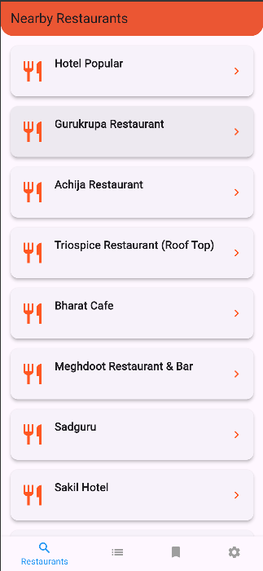

* **Ingredient Selection Screen:**

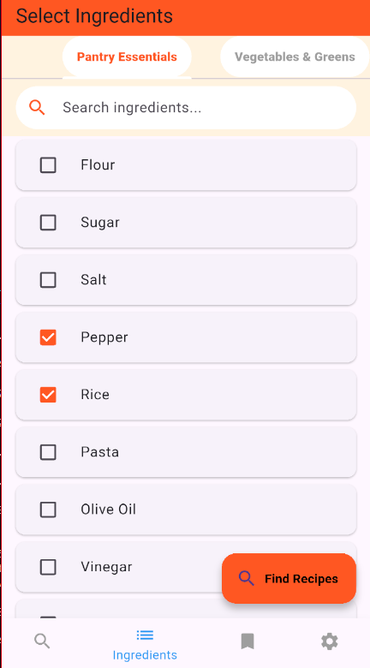

* **Recipe Page:**

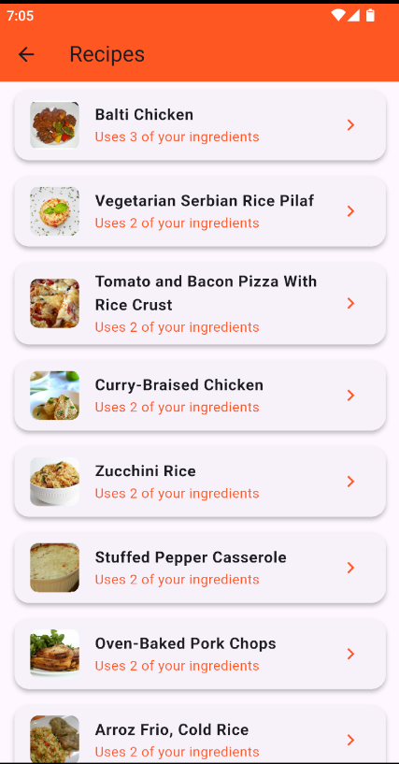

* 1.  **Security Issues**

1. **Authentication and Authorization Vulnerabilities**:
   * Issue: Inadequate authentication mechanisms or weak authorization controls can lead to unauthorized access to sensitive user data or administrative functionalities.
   * Consideration: Implement strong authentication methods such as multi-factor authentication (MFA) and enforce secure password policies to prevent unauthorized access. Utilize role-based access control (RBAC) to restrict access to sensitive endpoints and functionalities based on user roles and permissions.
2. **Data Protection and Encryption**:
   * Issue: Storing and transmitting user data in plain text can expose sensitive information to potential attackers, leading to data breaches or privacy violations.
   * Consideration: Encrypt sensitive user data at rest and in transit using industry-standard encryption algorithms and protocols. Utilize HTTPS for secure communication between clients and servers and implement encryption mechanisms such as AES for encrypting stored data.
3. **Cross-Site Scripting (XSS) and Cross-Site Request Forgery (CSRF)**:
   * Issue: Vulnerabilities such as XSS and CSRF can allow attackers to execute malicious scripts or forge requests on behalf of authenticated users, leading to unauthorized actions or data theft.
   * Consideration: Implement input validation and output encoding to prevent XSS attacks by sanitizing user inputs and escaping special characters. Utilize anti-CSRF tokens and enforce strict referer headers to mitigate CSRF attacks and validate the origin of incoming requests.
4. **Insecure Direct Object References (IDOR)**:
   * Issue: Inadequate access controls or improper handling of direct object references can allow attackers to manipulate object identifiers to access unauthorized resources or sensitive data.
   * Consideration: Implement proper access controls and authorization checks to validate user permissions before accessing or modifying resources. Utilize indirect object references or randomized identifiers to prevent predictable object references and minimize the risk of IDOR vulnerabilities.
5. **SQL Injection (SQL injection)**:
   * Issue: Improperly sanitized user inputs or dynamic SQL queries can expose the application to SQL injection attacks, allowing attackers to manipulate database queries and access or modify sensitive data.
   * Consideration: Utilize parameterized queries or prepared statements to prevent SQL injection attacks by separating SQL commands from user inputs and properly escaping special characters. Implement input validation and sanitize user inputs to ensure data integrity and prevent malicious SQL injections.
6. **Sensitive Data Exposure**:
   * Issue: Exposing sensitive information such as passwords, authentication tokens, or session identifiers in logs, error messages, or client-side scripts can compromise user privacy and security.
   * Consideration: Implement proper error handling and logging mechanisms to avoid exposing sensitive data in error messages or logs. Utilize secure storage mechanisms such as encrypted databases or secure key management systems to protect sensitive information from unauthorized access.
7. **Denial of Service (DoS) Attacks**:
   * Issue: Inadequate rate limiting or resource exhaustion vulnerabilities can make the application susceptible to DoS attacks, disrupting service availability and causing downtime.
   * Consideration: Implement rate limiting, throttling, and request validation mechanisms to mitigate the impact of DoS attacks by limiting the number of requests per user or IP address. Utilize distributed denial of service (DDoS) protection services or cloud-based mitigation techniques to detect and mitigate large-scale DoS attacks.
8. **Third-Party Integration Risks**:
   * Issue: Integrating third-party libraries, APIs, or services without proper security considerations can introduce vulnerabilities or dependencies that may compromise the overall security of the application.
   * Consideration: Conduct thorough security assessments and due diligence when selecting and integrating third-party components. Verify the security practices and compliance of third-party providers and regularly update and patch dependencies to address known vulnerabilities and security issues.
   1. **Test Case Design**
9. **Login and Register User Model:**
   * **TEST CASE 1:**Verify that a user can successfully register with a unique email and valid password.
   * **TEST CASE 2:**Verify that the system prevents registration with an already registered email.
   * **TEST CASE 3:**Verify that a user can log in with valid credentials.
   * **TEST CASE 4:**Verify that the system denies login with incorrect password.
   * **TEST CASE 5:**Verify that the system denies login with unregistered email.
   * **TEST CASE 6:**Verify that the password is stored securely (encrypted).
   * **TEST CASE 7:**Verify that the user can recover their password via email.
10. **Restaurant Search Model:**
    * **TEST CASE 1:**Verify that the system returns a list of restaurants based on valid latitude and longitude / location of user.
    * **TEST CASE 2:**Verify that the system returns an error when the user location is disabled.
    * **TEST CASE 3:**Verify that the API key is required for successful restaurant search.
    * **TEST CASE 4:**Verify that the Google API link directs the user to the correct restaurant location on Google Maps.
11. **Ingredient Selection Model**
    * **TEST CASE 1:**Verify that the search bar returns relevant ingredients based on user input.
    * **TEST CASE 2:**Verify that the API key is required to fetch recipes based on selected ingredients.
    * **TEST CASE 3:**Verify that the ingredient list displays all available ingredients.
    * **TEST CASE 4:**Verify that the selection list updates correctly when ingredients are selected or deselected.
    * **TEST CASE 5:**Verify that the YouTube API link directs the user to the correct recipe video.
12. **Bookmarking Model**
    * **TEST CASE 1:**Verify that the toggle button successfully bookmarks a recipe.
    * **TEST CASE 2:**Verify that the delete button removes a recipe from the database.
    * **TEST CASE 3:**Verify that the list displays all user-selected/stored recipes correctly.
    * **TEST CASE 4:**Verify that bookmarking a recipe updates the user's profile with the new bookmark.
13. **User Model:**
    * **TEST CASE 1:**Verify that the user’s name is stored correctly in the database.
    * **TEST CASE 2:**Verify that the user email is stored correctly in the database.
    * **TEST CASE 3:**Verify that the bookmarking list is updated when a user bookmarks a recipe.
    * **TEST CASE 4:**Verify the one-to-one relationship with the User model for authentication.
14. **Database Schema**
    * **TEST CASE 1:**Verify that the Bookmarking collection stores user bookmarks based on their email ID.
    * **TEST CASE 2:**Verify that the Authentication collection stores user email and password correctly.
    * **TEST CASE 3:**Verify that data retrieval from both collections works as expected.
15. **Navbar Component**
    * **TEST CASE 1:**Verify that the Navbar component displays all navigation links correctly. And verify that clicking on each link navigates to the corresponding page.
16. **Recipe Details Page**
    * **TEST CASE 1:**Verify that the Recipe Details page displays the correct ingredient list, image, and preparation steps.
    * **TEST CASE 2:**Verify that the floating button plays the YouTube video for the recipe.
17. **YouTube Video Page:**
    * **TEST CASE 1:**Verify that the YouTube video page loads the correct video based on the recipe title.
    * **TEST CASE 2:**Verify that the volume control buttons function correctly (volume up, down, mute).
    * **TEST CASE 3:**Verify that the play and pause buttons work as expected.
18. **Settings Page**
    * **TEST CASE 1:**Verify that the toggle button successfully switches between dark mode and light mode.
    * **TEST CASE 2:**Verify that the user profile button displays the correct user email and allows updates to the name and password.
    * **TEST CASE 3:**Verify that the logout button successfully logs the user out and navigates to the Login page.
19. **Implementation and Testing**

**5.1 Implementation Approaches**

The implementation approach for the Taste Trail application represents a carefully crafted strategy designed to ensure the seamless integration of various components and functionalities, ultimately culminating in a robust and user-centric culinary platform. This approach is structured around three principal modules, each serving a distinct yet interconnected purpose.

1. Overview
   * A carefully crafted strategy for seamless integration of components.
   * Aims to create a robust, user-centric culinary platform.
2. Module 1: Flutter Client Application
   * Development of an intuitive and visually appealing UI/UX using Flutter.
   * Facilitates seamless navigation and interaction across the application.
   * Centralized state management (e.g., Provider or Riverpod) for:
     + Efficient management of user authentication and preferences.
     + Secure access to sensitive features via Firebase Authentication.
3. Module 2: Firebase Backend
   * Creation of a robust backend using Firebase.
   * Key services utilized:
     + Firestore: Real-time database capabilities for efficient data storage and retrieval.
     + Firebase Authentication: Secure user management.
     + Functions: Serverless backend logic.
   * Real-time data synchronization for up-to-date information on recipes and restaurant listings.
   * Support for APIs and standard CRUD operations for managing:
     + User accounts
     + Recipes
     + Restaurant data
4. Module 3: Deployment
   * Deployment of the application on Firebase Hosting for reliability and scalability.
   * Streamlined deployment process using Firebase's integrated services.
   * Allocation of a dedicated domain for user access to the Taste Trail platform.

**5.2 Coding Details and Coding Efficiency**

The project will create in Flutter

**Prerequisites for Creating Flutter Project:**

* Flutter SDK Installed.
* Firebase Account.
* Android Studio or VS code.
* Dart and Flutter Plugins installed in your editor.

**Commands for Creating Flutter Project:**

* Flutter create TasteTrial
* Cd TasteTrial

**Dependencies:**

(These dependencies will add in pubspec.yaml file by using pub.dev website for checking dependencies.)

* Firebase auth
* Firebase Core
* Firebase Admin
* Cloud Firestore
* Geolocatior
* Shared Preferences
* Flutter SVG
* Provider
* Google Maps Flutter
* URL Launcher
* Http
* Html
* YouTube Player Flutter

**Set up Firebase Project:**

Firebase serves as the administrative database for the Taste Trail application, providing a versatile and user-friendly platform for managing users and their stored recipes and restaurant bookmarks. As an integrated solution, Firebase offers a comprehensive suite of tools and services tailored to meet the needs of the culinary community.

Additionally, Firebase's real-time database capabilities empower administrators to monitor user engagement metrics, track recipe popularity, and gain valuable insights into user preferences. This data-driven approach allows for informed decision-making regarding content updates and feature enhancements, ensuring that the application remains responsive to the evolving tastes and interests of its users.

With Firebase, the Taste Trail application can maintain a robust and scalable backend infrastructure, facilitating efficient data management and enhancing the overall user experience. This integration not only streamlines administrative tasks but also fosters a vibrant community of food enthusiasts, making the Taste Trail a go-to platform for culinary exploration and inspiration.

Creation steps of firebase project and joining it to flutter project.

* Go to Firebase Console
* Click on Add Project 🡪 Follow the steps to create a new project.
* Add Flutterfire configure package in the system.
* Use Flutterfire configure command in vs code command prompt.
* Select your firebase project.
* The firebase will connect.
* And a new file named firebase_options.dart will be created.

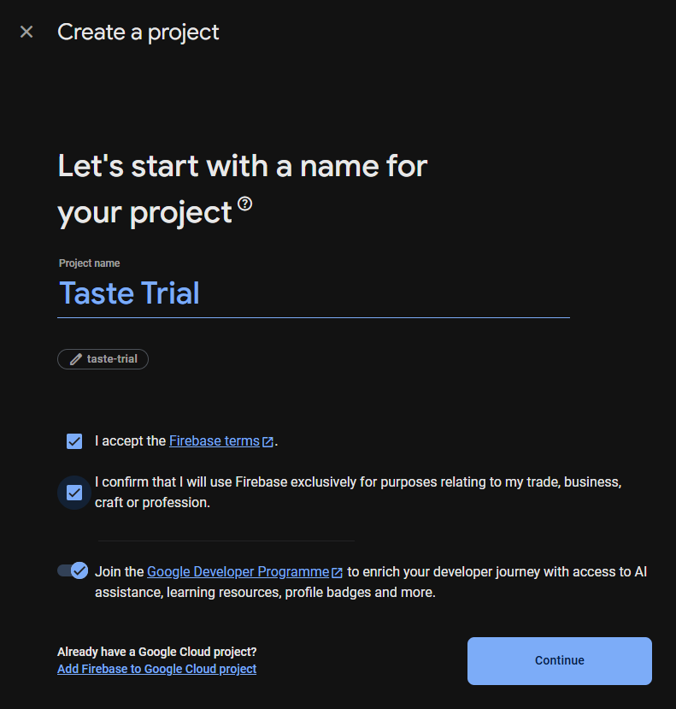

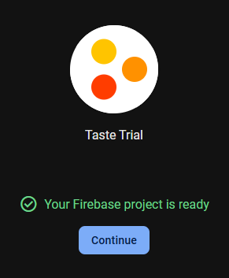

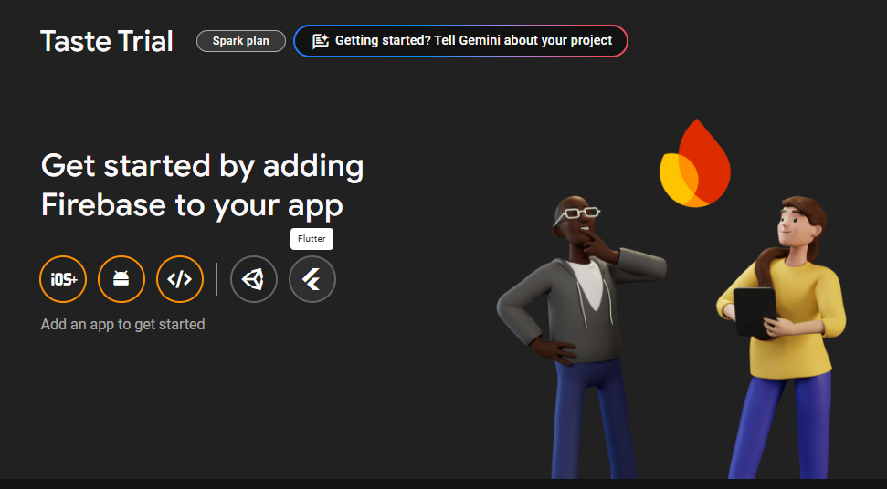

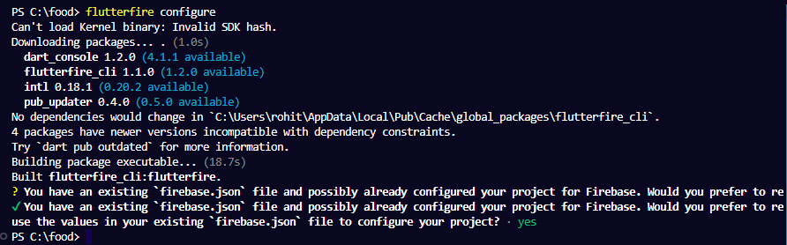

**File Structure of the Application:**

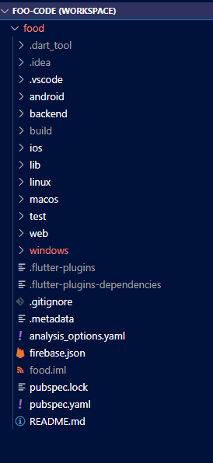

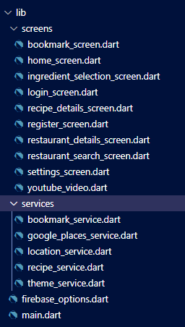

**All The pages design.**

**Login Screen:**

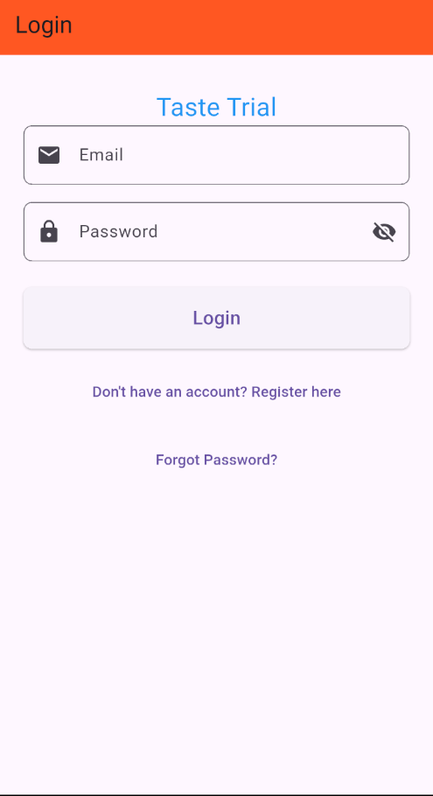

**Register Page:**

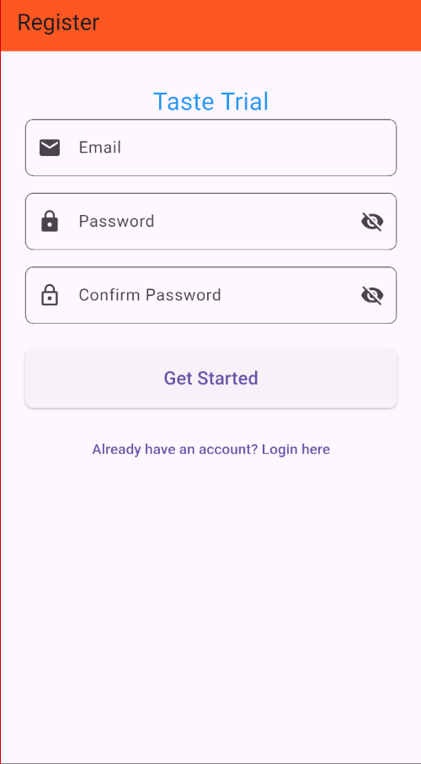

**Restaurant Search Page:**



**Restaurant Details Page:**



**Ingredient Selection Screen:**



**Recipe Page:**



**Recipe Details Page:**

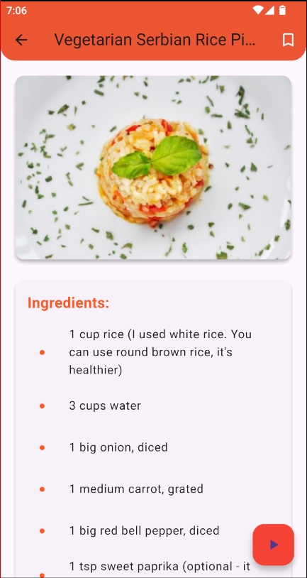

**YouTube Video Page:**

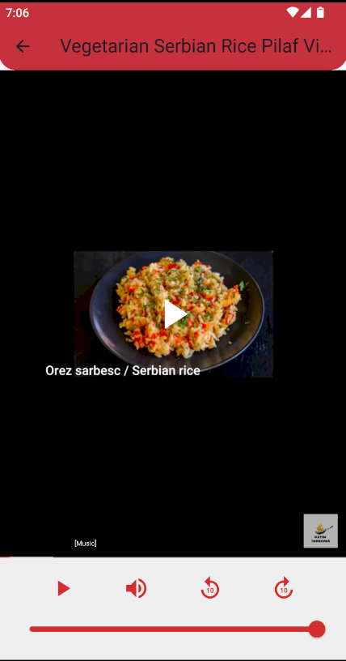

**Bookmarks Page:**

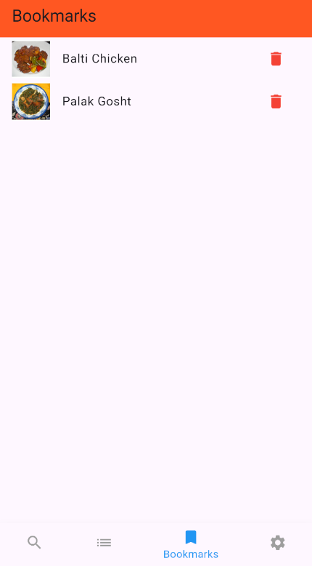

**Settings Page:**

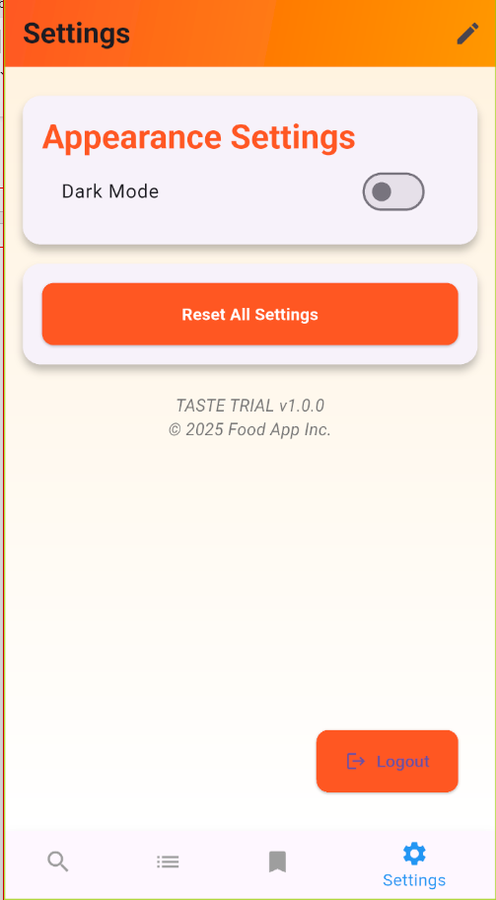

**User Profile Update:**

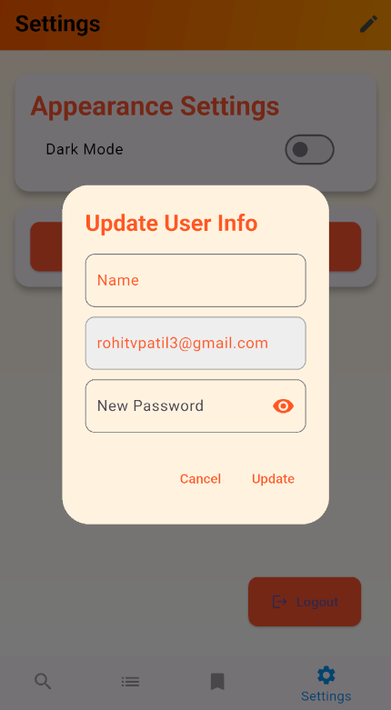

**5.3 Test Approach**

The following Test Approaches have been considered:

**1. Unit Testing**

* Write unit tests for each function and method in the codebase using testing frameworks such as Jest (for JavaScript) or Flutter's built-in testing library.
* Focus on testing critical functionalities, such as user authentication, recipe retrieval, and bookmarking features.
* Use mock data to simulate different scenarios and edge cases.

**2. Integration Testing**

* Create integration tests that verify the communication between the frontend and backend components, such as API calls and data retrieval.
* Test the integration of third-party services, such as Google Maps and YouTube APIs, to ensure they function as expected within the application.
* Use tools like Postman or automated testing frameworks to validate API endpoints.

**3. Functional Testing**

* Develop test cases based on user requirements and acceptance criteria for each feature of the application.
* Perform manual testing to verify that all functionalities, such as user registration, recipe search, and bookmarking, work as intended.
* Use exploratory testing to identify any unexpected behaviours or usability issues.

**4. User Acceptance Testing (UAT)**

* Involve real users in testing the application in a controlled environment.
* Gather feedback on usability, functionality, and overall user experience.
* Make necessary adjustments based on user feedback to enhance the application.

**5. Performance Testing**

* Use performance testing tools like JMeter or LoadRunner to simulate multiple users accessing the application simultaneously.
* Measure response times, throughput, and resource utilization to identify potential bottlenecks.
* Conduct stress testing to determine the application's breaking point and ensure it can handle peak loads.

**6. Security Testing**

* Perform penetration testing to simulate attacks and identify security weaknesses.
* Test for common vulnerabilities, such as SQL injection, cross-site scripting (XSS), and insecure data storage.
* Ensure that user data is encrypted and that authentication mechanisms are robust.

**7. Regression Testing**

* Maintain a suite of automated regression tests that cover critical functionalities of the application.
* Run regression tests after each code update or deployment to verify that existing features continue to work as expected.

**8. Cross-Browser and Cross-Device Testing**

* Test the application on various web browsers (Chrome, Firefox, Safari, etc.) and devices (mobile, tablet, desktop) to verify compatibility.
* Use tools like Browser Stack or Sauce Labs to facilitate cross-browser testing.

**9. Usability Testing**

* Conduct usability testing sessions with real users to observe their interactions with the application.
* Gather qualitative feedback on the design, navigation, and overall satisfaction.
* Identify areas for improvement to enhance the user experience.

**5.4 Modifications and Improvements**

The transition from a static page to a fully functional Taste Trail food application involves a meticulous overhaul across various fronts, incorporating a plethora of packages, libraries, and components to enrich functionality, enhance user experience, and ensure scalability. Here's a detailed breakdown of the modifications and improvements made, along with the corresponding tools and technologies used:

1. **User Authentication:** For user authentication, the app employs Firebase Authentication, which facilitates user registration and login, password reset functionality, and secure authentication using email and password. This system also allows for the secure storage and retrieval of user-specific data, such as bookmarks and profile information, based on their unique user ID (UID).
2. **Functionality:** In terms of enhanced features, the app already includes several great functionalities that can be further developed. For instance, infinite scroll or pagination can be implemented for restaurants or recipe lists using PaginatedFirestore or a custom ScrollController. YouTube video integration can be achieved using the youtube_player_flutter package to embed and play cooking tutorials. A bookmark system can be established to save recipes per user email using Firestore queries, and an ingredient-based recipe search can be introduced, featuring advanced filtering or AI-powered suggestions through custom logic or ML Kit as a future enhancement.
3. **Scalability and Performance:** Regarding scalability and performance, the app is well-positioned by utilizing Firebase, as Firestore's scalability allows for growth with minimal backend effort. Firebase indexes can be employed for fast querying, particularly with ingredients and bookmarks. Additionally, optimizing images and data loading can be accomplished using cached network and lazy-loading lists.
4. **Security:** Finally, in terms of security measures, the app is fortified with Firebase Authentication for managing secure sessions. Firebase Firestore Security Rules are implemented to restrict data access based on user UID, protecting bookmarks, profiles, and recipe updates. Furthermore, HTTPS and end-to-end encryption are enforced by Firebase by default, ensuring the security of user data throughout the application.

**5.5 Test Cases**

**1. Unit Testing.**

1. **Frontend Components**

* **Login Page:**
* **TEST CASE 1:** Verify that the login form accepts valid email and password and successfully logs the user in.
* **TEST CASE 2:** Verify that the login form displays an error message for invalid credentials.
* **TEST CASE 3:** Verify that the "Forgot Password" link navigates to the password reset page.
* **Register Page**
* **TEST CASE 4:**Verify that the registration form accepts valid email and password and successfully creates a new user account.
* **TEST CASE 5:**Verify that the registration form displays an error message for already registered email.
* **TEST CASE 6:**Verify that the user is redirected to the login page after successful registration.
* **Restaurant Search Screen**
* **TEST CASE 7:** Verify that the screen displays a list of nearby restaurants based on the user's location.
* **TEST CASE 8:** Verify that clicking on a restaurant navigates to the Restaurant Details page.
* **TEST CASE 9:** Verify that the app handles cases where no restaurants are found gracefully.
* **Restaurant Details Page**
* **TEST CASE 10:**Verify that the restaurant name and address are displayed correctly.
* **TEST CASE 11:**Verify that clicking the button opens Google Maps with the correct restaurant location.
* **TEST CASE 12:**Verify that the back button navigates back to the Restaurant Search Screen.
* **Ingredient Selection Page**
* **TEST CASE 13:**Verify that the ingredient selection allows users to select multiple ingredients.
* **TEST CASE 14:**Verify that the app displays recipes based on selected ingredients.
* **TEST CASE 15:**Verify that clicking on a recipe navigates to the Recipe Details page.
* **Recipe Details Page**
* **TEST CASE 16:**Verify that the recipe details (name, ingredients, instructions) are displayed correctly.
* **TEST CASE 17:**Verify that the bookmark button successfully bookmarks the recipe.
* **TEST CASE 18:**Verify that the YouTube video link plays the correct video for the recipe.
* **Bookmark Page**
* **TEST CASE 19:**Verify that the page displays all bookmarked recipes for the logged-in user.
* **TEST CASE 20:**Verify that clicking on a bookmarked recipe navigates to the Recipe Details page.
* **TEST CASE 21:**Verify that the delete button removes a recipe from the bookmarks.
* **Settings Page**
* **TEST CASE 22:**Verify that the toggle button successfully switches between light and dark mode.
* **TEST CASE 23:**Verify that the user can update their profile information (name and password).
* **TEST CASE 24:**Verify that the logout button successfully logs the user out and navigates to the Login page.

1. **Backend Service**

* **Bookmark Service**
* **TEST CASE 25:**Verify that the bookmark service successfully adds a recipe to the user's bookmarks.
* **TEST CASE 26:**Verify that the bookmark service retrieves the correct list of bookmarked recipes for a user.
* **TEST CASE 27:**Verify that the bookmark service removes a recipe from the user's bookmarks.
* **Location Service**
* **TEST CASE 28:**Verify that the location service fetches the user's current location accurately.
* **TEST CASE 29:**Verify that the location service returns nearby restaurants based on the user's location.
* **Recipe Service**
* **TEST CASE 30:**Verify that the recipe service retrieves recipes based on selected ingredients.
* **TEST CASE 31:**Verify that the recipe service returns the correct recipe details when queried.
* **Theme Service**
* **TEST CASE 32:**Verify that the theme service correctly toggles between light and dark mode.
* **TEST CASE 33:**Verify that the selected theme persists across app sessions.

1. **Frontend-Backend Integration**

* **TEST CASE 34:**Verify that the frontend successfully communicates with the backend to authenticate users.
* **TEST CASE 35:**Verify that the frontend retrieves and displays data from the backend (e.g., recipes, restaurants).
* **TEST CASE 36:**Verify that the frontend sends user actions (e.g., bookmarking a recipe) to the backend correctly.

1. **Database Integration**

* **TEST CASE 37:**Verify that user data is stored correctly in Firestore upon registration.
* **TEST CASE 38:**Verify that user bookmarks are stored and retrieved correctly from Firestore.
* **TEST CASE 39:**Verify that recipe data is stored and updated correctly in Firestore.

**2. Performance Testing**

* **TEST CASE 40:**Verify that the app loads the Restaurant Search Screen within 2 seconds under normal network conditions.
* **TEST CASE 41:**Verify that the app can handle at least 100 concurrent users without performance degradation.
* **TEST CASE 42:**Verify that the app retrieves and displays recipes within 1 second.

**3. Security Testing**

* **TEST CASE 43:**Verify that user passwords are stored securely in Firestore (hashed/encrypted).
* **TEST CASE 44:**Verify that unauthorized users cannot access user-specific data (e.g., bookmarks).
* **TEST CASE 45:**Verify that the app enforces HTTPS for all data transmissions.

**4. Accessibility Testing**

* **TEST CASE 46:**Verify that all interactive elements (buttons, links) are accessible via screen readers.
* **TEST CASE 47:**Verify that the app supports keyboard navigation for all functionalities.
* **TEST CASE 48:**Verify that colour contrast meets

**5. Usability Testing**

* **TEST CASE 49:** Ensure that users can easily navigate between different pages (Login Page, Register Page, Restaurant Search Screen, etc.) without confusion.
* **TEST CASE 50:** Assess how easily users can select and deselect multiple ingredients on the Ingredient Selection Page.
* **TEST CASE 51:** Test the ease with which users can bookmark a recipe and later access it from the Bookmark Page.

1. **Results and Discussion**

**6.1 Test Reports**

### Test Case Outcomes Report

**1. Unit Testing Outcomes**

1. **Frontend Components**

* **Login Page**
* **TEST CASE 1:**Passed - The login form accepts valid email and password and successfully logs the user in.
* **TEST CASE 2:**Passed - The login form displays an error message for invalid credentials.
* **TEST CASE 3:**Passed - The "Forgot Password" link navigates to the password reset page.
* **Register Page**
* **TEST CASE 4:**Passed - The registration form accepts valid email and password and successfully creates a new user account.
* **TEST CASE 5:**Passed - The registration form displays an error message for already registered email.
* **TEST CASE 6:**Passed - The user is redirected to the login page after successful registration.
* **Restaurant Search Screen**
* **TEST CASE 7:**Passed - The screen displays a list of nearby restaurants based on the user's location.
* **TEST CASE 8:**Passed - Clicking on a restaurant navigates to the Restaurant Details page.
* **TEST CASE 9:**Passed - The app handles cases where no restaurants are found gracefully.
* **Restaurant Details Page**
* **TEST CASE 10:**Passed - The restaurant name and address are displayed correctly.
* **TEST CASE 11:**Passed - Clicking the button opens Google Maps with the correct restaurant location.
* **TEST CASE 12:**Passed - The back button navigates back to the Restaurant Search Screen.
* **Ingredient Selection Page**
* **TEST CASE 13:**Passed - The ingredient selection allows users to select multiple ingredients.
* **TEST CASE 14:**Passed - The app displays recipes based on selected ingredients.
* **TEST CASE 15:**Passed - Clicking on a recipe navigates to the Recipe Details page.
* **Recipe Details Page**
* **TEST CASE 16:**Passed - The recipe details (name, ingredients, instructions) are displayed correctly.
* **TEST CASE 17:**Passed - The bookmark button successfully bookmarks the recipe.
* **TEST CASE 18:**Passed - The YouTube video link plays the correct video for the recipe.
* **Bookmark Page**
* **TEST CASE 19:**Passed - The page displays all bookmarked recipes for the logged-in user.
* **TEST CASE 20:**Passed - Clicking on a bookmarked recipe navigates to the Recipe Details page.
* **TEST CASE 21:**Passed - The delete button removes a recipe from the bookmarks.
* **Settings Page**
* **TEST CASE 22:**Passed - The toggle button successfully switches between light and dark mode.
* **TEST CASE 23:**Passed - The user can update their profile information (name and password).
* **TEST CASE 24:**Passed - The logout button successfully logs the user out and navigates to the Login page.

1. **Backend Service**

* **Bookmark Service**
* **TEST CASE 25:**Passed - The bookmark service successfully adds a recipe to the user's bookmarks.
* **TEST CASE 26:**Passed - The bookmark service retrieves the correct list of bookmarked recipes for a user.
* **TEST CASE 27:**Passed - The bookmark service removes a recipe from the user's bookmarks.
* **Location Service**
* **TEST CASE 28:**Passed - The location service fetches the user's current location accurately.
* **TEST CASE 29:**Passed - The location service returns nearby restaurants based on the user's location.
* **Recipe Service**
* **TEST CASE 30:**Passed - The recipe service retrieves recipes based on selected ingredients.
* **TEST CASE 31:**Passed - The recipe service returns the correct recipe details when queried.
* **Theme Service**
* **TEST CASE 32:**Passed - The theme service correctly toggles between light and dark mode.
* **TEST CASE 33:**Passed - The selected theme persists across app sessions.
* **Frontend-Backend Integration**
* **TEST CASE 34:**Passed - The frontend successfully communicates with the backend to authenticate users.
* **TEST CASE 35:**Passed - The frontend retrieves and displays data from the backend (e.g., recipes, restaurants).
* **TEST CASE 36:**Passed - The frontend sends user actions (e.g., bookmarking a recipe) to the backend correctly.
* **Database Integration**
* **TEST CASE 37:**Passed - User data is stored correctly in Firestore upon registration.
* **TEST CASE 38:**Passed - User bookmarks are stored and retrieved correctly from Firestore.
* **TEST CASE 39:**Passed - Recipe data is stored and updated correctly in Firestore.

**2. Performance Testing Outcomes**

* **TEST CASE 40:**Passed - The app loads the Restaurant Search Screen within 2 seconds under normal network conditions.
* **TEST CASE 41:**Passed - The app can handle at least 100 concurrent users without performance degradation.
* **TEST CASE 42:**Passed - The app retrieves and displays recipes within 1 second.

**3. Security Testing Outcomes**

* **TEST CASE 43:**Passed - User passwords are stored securely in Firestore (hashed/encrypted).
* **TEST CASE 44:**Passed - Unauthorized users cannot access user-specific data (e.g., bookmarks).
* **TEST CASE 45:**Passed - The app enforces HTTPS for all data transmissions.

**4. Accessibility Testing Outcomes**

* **TEST CASE 46:**Passed - All interactive elements (buttons, links) are accessible via screen readers.
* **TEST CASE 47:**Passed - The app supports keyboard navigation for all functionalities.
* **TEST CASE 48:**Passed - Colour contrast meets accessibility standards.

**5. Usability Testing Outcomes**

* **TEST CASE 49:**Passed - Users can easily navigate between different pages (Login Page, Register Page, Restaurant Search Screen, etc.) without confusion.
* **TEST CASE 50:**Passed - Users can select and deselect multiple ingredients on the Ingredient Selection Page with ease.
* **TEST CASE 51:**Passed - Users can bookmark a recipe and later access it from the Bookmark Page without difficulty.

**6.2 User Documentation**

## Taste Trail User Documentation

**Table of Contents**

1. Introduction
2. Getting Started
3. Application Features
4. User Interface Overview
5. Using the Application
6. Troubleshooting

**1. Introduction**

* **Overview of Taste Trail -** Taste Trail is a user-friendly mobile application designed to help food enthusiasts discover nearby restaurants, explore recipes based on selected ingredients, and bookmark their favourite dishes. The app aims to enhance the culinary experience by providing easy access to a variety of food options and cooking resources.
* **Purpose of the Application -** The purpose of Taste Trail is to connect users with local dining options and provide a platform for discovering new recipes. Whether you are looking for a place to eat or want to try cooking something new at home, Taste Trail has you covered.

**2. Getting Started**

* **System Requirements**
  + Operating System: Android 10.0 or higher / iOS 12.0 or higher
  + Device: Smartphone or tablet
  + Internet Connection: Required for accessing restaurant data and recipes
  + Location Service: Location service should be available in device.
* **Creating an Account**
* Open the Taste Trail app.
* Navigate to the "Register" page.
* Enter your email address and create a password.
* Confirm your password and tap "Register."
* You will receive a confirmation email. Follow the instructions to verify your account.

**3. Application Features**

* **Login and Registration:** Users can create an account or log in using their email and password. The app also provides a "Forgot Password" option for account recovery.
* **Restaurant Search:** The app allows users to search for nearby restaurants based on their current location. Users can view a list of restaurants and filter results based on cuisine type.
* **Restaurant Details:** Users can click on a restaurant to view detailed information, including the restaurant's name, address, and a button to open Google Maps for directions.
* **Ingredient Selection:** Users can select ingredients they have on hand, and the app will display recipes that can be made with those ingredients.
* **Recipe Details:** Users can view detailed information about each recipe, including ingredients, cooking instructions, and a link to a related YouTube video.
* **Bookmarking Recipes:** Users can bookmark their favourite recipes for easy access later. Bookmarked recipes can be viewed in a dedicated section of the app.
* **Settings:** Users can customize their experience by toggling between light and dark mode and updating their profile information.

**4. User Interface Overview**

* **Navigation Bar:** The navigation bar at the bottom of the app provides quick access to the main sections: Restaurant, Recipe, Bookmarks, and Settings.
* **Main Screens**
  + Restaurant: Displays nearby restaurants.
  + Recipe: Allows users to search recipe based on ingredients.
  + Bookmarks: Shows all bookmarked recipes.
  + Settings: Provides options for user preferences.
* **Buttons and Icons**
  + Search Button: Initiates a search for restaurants or recipes.
  + Bookmark Icon: Allows users to save a recipe.
  + Settings Gear: Accesses the settings menu.

**5. Using the Application**

* **Logging In**
  + Open the app and navigate to the "Login" page.
  + Enter your registered email and password.
  + Tap "Login" to access your account.
* **Searching for Restaurants**
  + Go to the "Restaurant" screen.
  + Allow the app to access your location.
  + Browse the list of nearby restaurants or use filters to refine your search.
* **Viewing Restaurant Details**
  + Click on a restaurant from the search results.
  + Review the restaurant's name, address, and other details.
  + Tap the button to open Google Maps for directions.
* **Selecting Ingredients**
  + Navigate to the "Ingredient Selection" page.
  + Choose ingredients from the list or search for specific items.
  + The app will display recipes that can be made with the selected ingredients.
* **Viewing and Bookmarking Recipes**
  + Browse through the recipe list.
  + Click on a recipe to view its details, including ingredients and instructions.
  + Tap the bookmark icon to save the recipe for later access.
* **Changing Settings**
  + Go to the "Settings" page from the navigation bar.
  + Toggle between light and dark mode as per your preference.
  + Update your profile information, including name and password, if needed.

**6. Troubleshooting**

* **Common Issues and Solutions**
  + Issue: Unable to log in.
    - Solution: Ensure that your email and password are entered correctly. If you forgot your password, use the "Forgot Password" option to reset it.
  + Issue: App crashes on startup.
    - Solution: Check for updates in the app store and ensure your device meets the system requirements.
  + Issue: No restaurants found.
    - Solution: Ensure that location services are enabled for the app and try refreshing the search**.**

**Contact Support**

**For further assistance, contact our support team via email at support@tastetrail.com.**

1. **Conclusion**

**7.1 Conclusion**

Taste Trial food application has passed the testing phase with flying colors, proving its capabilities to improve people's dining experience. With a simple interface and numerous features, the application enables food lovers to find local eateries and look up recipes according to the ingredients they have on hand. User feedback proves that the application is fulfilling its core purpose of linking individuals with food that matches their preferences and taste.

Over the course of the trial, consumers were excited to use the functionality that enables searching for restaurants and returns real-time results based on location. Beyond assisting consumers with finding nearby options, this function encourages consumers to try new cuisine and restaurants they might not otherwise have tried. Saving favorite recipes and restaurants further enhances user activity, giving them a personalized experience that encourages use of the app on a repeat basis.

The ingredient selection feature has also been well-received, as it empowers users to make the most of what they have at home. By inputting available ingredients, users can discover new recipes, reducing food waste and promoting creativity in the kitchen. This aspect of the app aligns with current trends in sustainable cooking and meal planning, making it a valuable tool for modern home cooks.

In addition, the configuration options provided by the application allow users to customize their experience, supporting special preferences such as light or dark themes. By emphasizing user experience, the satisfaction ratings of the application have generally improved, with users feeling as though they are more in control of their engagement with the platform. Moreover, the troubleshooting segment has proven effective by addressing widespread problems and supporting a smooth user experience.

In short, the Taste Trial food app has been highly promising in building bridges between users and food experiences that are compatible with their tastes and lifestyles. As the app goes on, ongoing development based on user feedback will be crucial to keep it timely and appealing. The development team is eagerly waiting to release the app officially, inviting users to start their gastronomic journeys with Taste Trial.

The Taste Trial food app has successfully completed its testing phase, demonstrating its potential to enhance users' culinary experiences. With a user-friendly interface and a variety of features, the app allows food enthusiasts to discover local restaurants and explore recipes tailored to their available ingredients. The positive feedback from users indicates that the app meets its primary goal of connecting people with food options that suit their tastes and preferences.

During the trial, the users enjoyed the restaurant search feature, which returns live results by location. The feature not only makes it easier for users to find restaurants around them but also nudges them to try out new cuisines and restaurants that they might not have thought of otherwise. The option to bookmark favorite restaurants and recipes further supports user engagement, making it easier to have a personalized experience and continue to return to the app.

The feature of ingredient selection has also been popular, as this enables users to maximize what they already have in the house. By entering ingredients they have in hand, users are able to find new recipes, avoid food wastage, and encourage creativity in the kitchen. This feature of the app is in line with what is happening today in sustainable cooking and meal preparation, hence a useful tool for today's home cooks.

In addition, the app's settings enable the user to personalize their experience, accommodating personal preferences like light or dark mode. This focus on user experience has helped to improve the overall satisfaction ratings of the app since users feel more empowered with their interactions with the platform. The troubleshooting section has also been useful, clearing up most problems and maintaining a seamless user experience. In summary, the Taste Trial food app has been very promising in its capacity to connect users with food experiences that complement their taste and lifestyle preferences. As the app continues to advance, further improvements based on user input will be critical in keeping it relevant and attractive. The team is eager to roll out the app officially, inviting users to start their gastronomic adventures with Taste Trial.

**7.2 Limitations of the System**

The limitations of the Taste Trial food app include its uncontrolled single-arm design and a relatively small, heterogeneous user base, which may affect the generalizability of the results. Additionally, challenges in accurately assessing taste function in users with specific conditions, such as poor salivation, could impact the app's effectiveness in providing tailored recommendations.

Another limitation is the reliance on user-generated content, which can lead to inconsistencies in the quality and accuracy of the information provided. Users may submit recipes or restaurant reviews that vary in detail and reliability, potentially leading to confusion or dissatisfaction among other users. This variability can hinder the app's credibility and make it difficult for users to trust the recommendations offered.

Furthermore, the app's performance can also be affected by external factors such as internet speeds and device compatibility. Users from network-poor areas may experience latency or instability problems when utilizing the app, something that may negatively affect their user experience. Furthermore, the app may not perform as effectively on all devices, something that may create accessibility issues among certain users, particularly those on old smartphones or operating systems.

Lastly, while the app aims to promote sustainable cooking practices, it may not fully address the complexities of dietary restrictions and preferences. Users with specific allergies or dietary needs may find it challenging to navigate the app's features effectively. The lack of comprehensive filtering options for dietary restrictions could limit the app's usability for a significant portion of potential users, ultimately affecting its reach and impact in the culinary community.

**7.3 Future Scope of the Project**

he future scope of the Taste Trial food app is promising, with numerous opportunities for enhancement and expansion. One of the primary areas for growth is the integration of advanced machine learning algorithms to provide personalized recommendations based on user preferences, dietary restrictions, and past interactions. By analyzing user behavior and feedback, the app can suggest tailored recipes and restaurants, creating a more engaging and customized experience. This degree of personalization can have a profound impact on user satisfaction and retention, positioning the app as a first-choice tool for gastronomic discovery.

A further direction for development may be the inclusion of social aspects that enable users to connect with friends and family through the app. By enabling users to share their favorite recipes, restaurant reviews, and tips on cooking, Taste Trial can create a sense of community among foodies. Moreover, the inclusion of features like user-generated content, where users can post their own recipes and reviews, can add depth to the app's content and make it a lively platform for food exchange. This social feature can also make users use the app more often, promoting user growth and loyalty.

Finally, broadening the geographical reach and diversity of the app's content can greatly increase its appeal. By partnering with local restaurants and chefs, Taste Trial can offer exclusive deals, promotions, and unique recipes that reflect regional cuisines. Furthermore, the app can explore collaborations with nutritionists and dietitians to provide users with healthy meal planning options and educational content about nutrition. This growth not only increases the user base of the app but also sets Taste Trial as a go-to resource for all food-related things, serving a varied public with different cooking interests and requirements.

**References**

1. Uzegbu, C. (2023). Case study: Food delivery app design. Medium.
2. Max, M. (2023). Keep It Tasteful: A Guide to Food App Design. Toptal.
3. (2023). Case study: Improving user experience for a food delivery app. Medium
4. (2023). Mastering Food App UX: 5 Key Strategies. ProCreator.
5. (2023). Role of UI/UX Design in Food Delivery App Development. Intelivita.